

**Complain Management Platform**

**Submitted by**

Omer Faruq Nadim

171-35-1934

Department of Software Engineering

Daffodil International University

**Supervised by**

S A M Matiur Rahman

Associate Professor

Department of Software Engineering

Daffodil International University

This Project report has been submitted in fulfillment of the requirements for the Degree of

Bachelor of Science in Software Engineering.

© All right Reserved by Daffodil International University

# APPROVAL

This project titled on “Complain Management Platform”, submitted by Omer Faruq Nadim (ID: 171-35-1934) to the Department of Software Engineering, Daffodil International University has been accepted as satisfactory for the partial fulfillment of the requirements for the degree of Bachelor of Science in Software Engineering and approval as to its style and contents.

## DECLARATION

I hereby declare that project titled “Complain Management Platform” has been completed by me under the supervision of Mr. S A M Matiur Rahman, Associate Professor, Department of Software Engineering, Daffodil International University for the purpose of achieving degree of Bachelor of Science from Daffodil International University. This is also declared by me that neither this project nor any part of this project has been used or submitted elsewhere for any kind of degree or awards.

## ACKNOWLEDGEMENT

First and foremost, I want to praise Almighty God for all of His blessings during my project work, which gave me perseverance and helped me to finish on time. So, I consider myself quite privileged to have completed this project.

All of them are the product of such observations and assistance, for which I am grateful. I also like to thank and acknowledge my supervisor, Mr. S A M Matiur Rahman, Associate Professor, Department of Software Engineering, Daffodil International University, Dhaka.

He knew a lot about the software industry, and his solid judgment, supervision, and high competence level aided me much in my project. When I need to oversee, he is always available.

I would like to convey my gratitude and gratitude to Dr. Imran Mahmud, Associate Professor and Head of the Department of Software Engineering, for his thoughtful review of my project, which helped me to actually accomplish it.

I would also want to thank the other academic and staff members of Daffodil International University's Department of Software Engineering for their warmth and helpful attitude toward us.

I'd want to thank everyone of my Daffodil International University students that participated in this debate while taking the course. I would also like to thank other faculty and staff members of Daffodil International University's Software Engineering department for their friendliness and helpful attitude toward us.

I'd want to thank everyone of my Daffodil International University students who participated in this debate while doing school work.

Finally, and most significantly, I must express my deepest gratitude for their constant support and patience.

## ABSTRACT

The "Complaint Management Platform" project is intended to digitally gather university student complaint resolution surveys. The project is built on a web application that provides a major way to organize, monitor, manage, and handle student grievances.

Providing the University with a powerful tool for identifying and targeting specific problems, tracking complaint handling performance, and improving resolution procedures.

Complain Management Platform (CMP) is an online complaint management system that provides students with instant access to a variety of information and gathers legitimate concerns that students confront on their campus.

**Table of Content**

APPROVAL i

DECLARATION ii

ACKNOWLEDGEMENT iii

ABSTRACT iv

CHAPTER 01 1

Introduction 1

1.1 Project Overview 1

1.2 Project Purpose 1

Benefits 2

Beneficiaries 2

1.3 Proposed System Model 2

CHAPTER 02 5

SOFTWARE REQUIREMENT SPECIFICATION 5

2.1 Functional Requirement 5

2.2 Performance Requirement 7

2.3 Dependability Requirement 7

2.4 Maintainability and Supportability Requirement 8

• Provide a user guide. 8

• Provide FAQ for a better user experience. 8

2.5 Security Requirement 8

CHAPTER 03 9

SYSTEM ANALYSIS 9

Introduction: 9

3.1 Use Case 10

3.1.2 Use Case for Admin 15

3.1.3 Use Case for Authority 19

3.4 ERD Diagram 55

CHAPTER 04 56

DEVELOPMENT TOOLS & TECHNOLOGY 56

4.1 User Interface Technologies 56

4.2 Implementation Technologies 56

4.3 Platform & Environment 56

CHAPTER 05 58

SYSTEM TESTING 58

5.1 Introduction 58

The purpose of system testing is to find flaws. This activity's major goal is to verify that the procedure is effectively conveyed and that all requirements are satisfied. System testing is important for assessing whether or not a function is functioning properly. 58

5.2 Test Case 58

Test Case No -1 58

Testing Case, No-2 58

Testing Case, No-3 59

Testing Case, No-4 60

CHAPTER 06 61

USER MANUAL 61

6.1 User manual 61

FOR User 61

For Admin 68

For Authority 73

CHAPTER 07 77

PROJECT SUMMARY 77

7.1 GitHub Link: 77

7.2 Limitations: 77

7.3 Obstacle & Achievement 77

Obstacle: 77

Achievement: 77

7.4 Future Work 77

References 78

**List of Figures**

1.3.1 Agile Model 11

1.3.2 Gannt Chart 12

2.1.1 Functional Requirement for User 13

2.1.2 Functional Requirement for Admin 14

2.1.3 Functional Requirement for Authority 15

3.1.1 Use Case 17

3.2.1.1 User Login 29

3.2.1.2 User Registration 30

3.2.1.3 User Password Change 31

3.2.1.4 User Assign Complain 32

3.2.1.5 User View Complain 33

3.2.1.6 User Edit Complain 34

3.2.1.7 User Assign Suggestion 35

3.2.1.8 User View Suggestion 36

3.2.1.9 User Edit Suggestion 37

3.2.1.10 User Complain Details 38

3.2.1.11 User Complain Status 39

3.2.1.12 User Get Help 39

3.2.2.1 Admin Login 40

3.2.2.2 Admin Complain 41

3.2.2.3 Admin Update Complain 42

3.2.2.4 Admin Complain Approve 43

3.2.2.5 Admin User Details 44

3.2.2.6 Admin User Help 45

3.2.2.7 Admin User Suggestion Details 46

3.2.2.8 Admin Generate Report 47

3.2.3.1 Authority Login 49

3.2.3.2 Authority View User 50

3.2.3.3 Authority User Complain 51

3.2.3.4 Authority User Suggestion 52

3.2.3.5 Authority Report Check 53

3.3.1.1 Sequrence Diagram User login 54

3.3.1.2 Sequrence Diagram User Registration 55

3.3.1.3 Sequrence Diagram User Complain and Suggestion 56

3.3.1.4 Sequrence Diagram User Main Options 57

3.3.2.1 Sequrence Diagram Admin login 58

3.3.2.1 Sequrence Diagram Admin Main Options 59

3.3.2.1 Sequrence Diagram Admin Notice Update 60

3.3.3.1 Sequrence Diagram Authority Login 61

3.3.2.2 Sequrence Diagram Authority Main options 62

3.4.1 ERD Diagram 63

Fig 6.1.1 User Login Page 70

Fig 6.1.2 User Registration Page 70

Fig 6.1.3.1 User Dashboard 1 Page 71

Fig 6.1.3.2 User Dashboard 2 Page 71

Fig 6.1.3.3 User Dashboard 3 Page 72

Fig 6.1.4 User Complain 72

Fig 6.1.5 User Complain View 73

Fig 6.1.6 User Suggestion 73

Fig 6.1.7 User Suggestion View 74

Fig 6.1.8 User Notice Board 74

Fig 6.1.9 User Helpline 75

Fig 6.1.10 User Profile 75

Fig 6.1.11 User Notification 76

Fig 6.2.1 Admin Login 76

Fig 6.2.2 Admin Dashboard 77

Fig 6.2.3 Admin User List 77

Fig 6.2.4 Admin User Complain 78

Fig 6.2.5 Admin User Suggestion 78

Fig 6.2.6 Admin Notice Add 79

Fig 6.2.7 Admin Notice Show 79

Fig 6.2.8 Admin User Complain Approve 80

Fig 6.2.9 Admin Profile Update 80

Fig 6.3.1 Authority Login 81

Fig 6.3.2 Authority Dashboard 1 81

Fig 6.3.2 Authority Dashboard 2 82

Fig 6.3.3 Authority User List 82

Fig 6.3.4 Authority User Complain 83

Fig 6.3.5 Authority User Suggestion 84

Fig 6.3.6 Authority Complain Approve 84

Fig 6.3.7 Authority Profile Update 85

## CHAPTER 01

## Introduction

### 1.1 Project Overview

Complain Management System provides a web-based solution to student problems that saves time, minimizes annoyance, and provides a quick solution.

The project's purpose is to make it quicker to organize, monitor, manage, and deal with complaints, as well as to provide the campus with an effective tool for identifying and targeting problem areas, tracking complaints handling performance, and improving business processes.

Complain Management System is an online complaint management system that is intended to respond to student issues as quickly as possible that saves time by providing students with an online alternative to resolve their complaints while being linked to the varsity administrator.

The Complaint Management System intends to enhance the ability to monitor, track, and resolve issues, offering the University with an efficient tool for identifying issues, monitoring the effectiveness of complaint management, and enhancing the campus.

Students may employ this strategy to save time and reduce misconduct in the classroom.

The proposed technique eliminates the need for students to go to the coordinator's office to resolve issues. He can get his problem fixed by publishing it in this suggested system, and he can also provide a possible solution to the problems that have been reported on the system.

In a private university, there is no direct communication between the administration (coordinator) and the students in an efficient manner for problem solving, i.e., to get a problem solved in our campus, we have to bribe the officials and get it solved in two months when it can be solved in one month.

### 1.2 Project Purpose

#### 1.2.1 Project Background

In the digital Bangladesh century, every problem must be tackled digitally. We have several obstacles at times in managing a big varsity campus that is ideal for students. We can readily communicate our concern to our varsity authorities using this digital campaign "Complaint Management System," and we can easily obtain a solution to that problem.

#### 1.2.2 Benefits & Beneficiaries

### Benefits

• Users may simply submit ideas to authorities using the system.

• Users can also submit complaints to authorities via the system.

• Users can receive alerts if they accept or reject complaints.

• Users can seek assistance from the help line via live chat.

• University notifications are available in the dashboard notice area.

### Beneficiaries

* Student (User)
* Admin
* Super Admin

#### 1.2.3 Goals

* Offer a digital solution
* Simple automated system
* Provide the report anonymously.
* Improve the campus.
* Improve student convenience on campus.
* Organizations Providing all university notifications.

### 1.3 Proposed System Model

A software model is an organized representation of a software process. Each Model illustrates a process from a unique perspective.

#### 1.3.1 Agile Model

Agile seems to be the model we propose. In software, the Agile Model terminology signifies the ability to adjust to technological changes and people as required. Engineering terminology performed by functional team. [1]

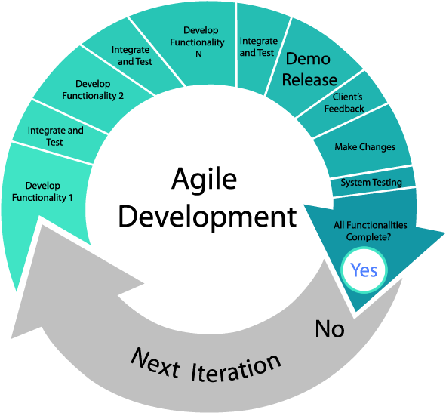

Fig 1.3.1 Agile Model

#### 1.3.2 Gantt Chart

|  |  |  |  |  |  |  |  |  |  |  |  |  |  |  |  |  |
| --- | --- | --- | --- | --- | --- | --- | --- | --- | --- | --- | --- | --- | --- | --- | --- | --- |
| Activities |  | W1 | W2 | W3 | W4 | W5 | W6 | W7 | W8 | W9 | W10 | W11 | W12 | W13 | W14 | W15 |
| Planning | Ideas |  |  |  |  |  |  |  |  |  |  |  |  |  |  |  |
| Problem definition |  |  |  |  |  |  |  |  |  |  |  |  |  |  |  |
| Proposal planning |  |  |  |  |  |  |  |  |  |  |  |  |  |  |  |
| Requirements | Requirement  Specification |  |  |  |  |  |  |  |  |  |  |  |  |  |  |  |
| Requirement  analysis |  |  |  |  |  |  |  |  |  |  |  |  |  |  |  |
| QA -1 | Quality assurance |  |  |  |  |  |  |  |  |  |  |  |  |  |  |  |
| System Design | Design specification |  |  |  |  |  |  |  |  |  |  |  |  |  |  |  |
| Interface design |  |  |  |  |  |  |  |  |  |  |  |  |  |  |  |
| Database design |  |  |  |  |  |  |  |  |  |  |  |  |  |  |  |
| Development | Development system modules  Integrate system modules |  |  |  |  |  |  |  |  |  |  |  |  |  |  |  |
|  |  |  |  |  |  |  |  |  |  |  |  |  |  |  |
| QA -2 | Test Cases |  |  |  |  |  |  |  |  |  |  |  |  |  |  |  |
| Testing | Black box testing |  |  |  |  |  |  |  |  |  |  |  |  |  |  |  |
|  |  |  |  |  |  |  |  |  |  |  |  |  |  |  |
| Resolve Issues | Resolve issues  found |  |  |  |  |  |  |  |  |  |  |  |  |  |  |  |
| Release | Software release |  |  |  |  |  |  |  |  |  |  |  |  |  |  |  |

Fig 1.3.2 Gantt Chart

## CHAPTER 02

## SOFTWARE REQUIREMENT SPECIFICATION

### 2.1 Functional Requirement

**For User**

|  |  |  |  |  |
| --- | --- | --- | --- | --- |
| **RQ ID** | **RQ Name** | **Description** | **RQ Type** | **Priority** |
| 1 | Login | Users can log in with own username and password. | Functional | High |
| 2 | Registration | Users can register on the system by providing all the necessary information. | Functional | High |
| 3 | Assign Complains | Users can post any type of complain with a detailed explanation. | Functional | High |
| 4 | Assign Suggestions | Users can submit Specific recommendations of any category with an explanation. | Functional | Mid |
| 5 | View Complain | The user can access their assigned review. | Functional | Mid |
| 6 | Update Complain | The user can make changes to their complaint. | Functional | Mid |
| 7 | View Suggestion | The user can view the Suggestion that has been assigned to them. | Functional | Mid |
| 8 | Get Help | Users can get assistance from the Helpline through Live Chat. | Functional | Mid |
| 9 | Get Notification | Every notice may be obtained from the university notice board. | Functional | Mid |

Fig 2.1.1 Functional Requirement for user

**For Admin:**

|  |  |  |  |  |
| --- | --- | --- | --- | --- |
| **RQ ID** | **RQ Name** | **Description** | **RQ Type** | **Priority** |
| 1 | Login | Admin can log in with own username and password. | Functional | High |
| 2 | See All Complains | Admin has access to all User Complaint Submissions. | Functional | High |
| 3 | Solve the problem | Admin can manually solve the problem and assign this to the system as a way to solve. | Functional | High |
| 4 | Change Status | Admin can accept user suggestions and complaints. | Functional | High |
| 5 | Generate Report | If an administrator approves a complaint, an email is sent to the admin. | Functional | High |
| 6 | Manage Account | The user account can be updated or deleted by the administrator. | Functional | High |
| 7 | View User list | The administrator can view the user list. | Functional | High |
| 8 | Give Solution | Admin may provide emergency support to users via live Chat. | Functional | High |
| 9 | Give Notice | The administrator has the ability to upload notices to the system. | Functional | High |
| 10 | View Notice | Admin has access to the Notice that has been uploaded. | Functional | Mid |

Fig 2.1.2 Functional Requirement for Admin

**For Authority**

|  |  |  |  |  |
| --- | --- | --- | --- | --- |
| **RQ ID** | **RQ Name** | **Description** | **RQ Type** | **Priority** |
| FC.A.RQ 1 | Login | Authority can log in with own username and password. | Functional | High |
| FC.A.RQ 2 | View Complains | Authority has access to all User Complaint Submissions | Functional | High |
| FC.A.RQ 3 | View Suggestions | Authority Admin has access to all User Suggestions Submissions | Functional | High |
| FC.A.RQ 4 | User complain approve | The authority has the power to approve a user's complaint request. | Functional | High |
| FC.A.RQ 5 | View all user list | The Authority can view the user list. | Functional | High |
| FC.A.RQ 6 | Check Report | The administrator's report can be evaluated or verified by the authority. | Functional | High |

Fig 2.1.3 Functional Requirement for Authority

### 2.2 Performance Requirement

#### 2.2.1 Speed and Latency Requirement

#### Data would be inserted into the MySQL database in a number of seconds.

#### Database queries would respond quickly and provide results in a matter of seconds.

#### The system GUI should load in 3 seconds.

#### However, it is subject to machine and internet speed.

#### Precisions Requirements

* Following the successful login, the user should display the correct result.
* All complain and application data should be correct and validly stored in the database.
* A particular complaint and application would be viewed by a certain user.
* Only registered users can make changes to their complaint information.

### 2.3 Dependability Requirement

#### 2.3.1 Reliability Requirements

* The user registration should create a new user and update the database with the provided information.
* Only accurate information can be used to get access to the system.
* If a person forgets their password, they can change it.
* Every new user must validate their email address on their initial login.
* Every user has the ability to amend their complaint information.
* This system should be accessible via a web browser.
* Upon user request, this system should perform operations promptly.
* This system's design is responsive, making it suitable for any device (Mobile, Tab, PC).

### 2.4 Maintainability and Supportability Requirement

#### 2.4.1 Maintenance Requirement

#### Modify the system as the application environment changes.

#### Fix a problem when the system is corrupted.

#### Correct user-inadvertent data errors.

#### 2.4.2 Supportability Requirements

### Provide a user guide.

### Provide FAQ for a better user experience.

### 2.5 Security Requirement

#### 2.5.1 Access Requirement

* Only registered and email-verified users can access the system.
* Only the administrator may authorize a user complaint.
* Only particular email addresses and passwords will be accepted for Authority/Admin login.
* Admin and Authority can investigate user complaints.
* The administrator can send an email notification to the authority.

## CHAPTER 03

## SYSTEM ANALYSIS

### Introduction:

In general, system development is divided into two parts: data integration and computer engineering. Software architecture refers to the process of designing a new system or expanding or augmenting an existing system. But, before we begin planning, we must thoroughly examine the existing system and identify how technology might best be leveraged to increase production.

Network analysis is the method of collecting and analyzing data, detecting issues, and using the findings to propose changes happen. The systems analyst is in charge of this. It is the process of creating a new or improved business system and describing its components to meet specific needs.

### 3.1 Use Case

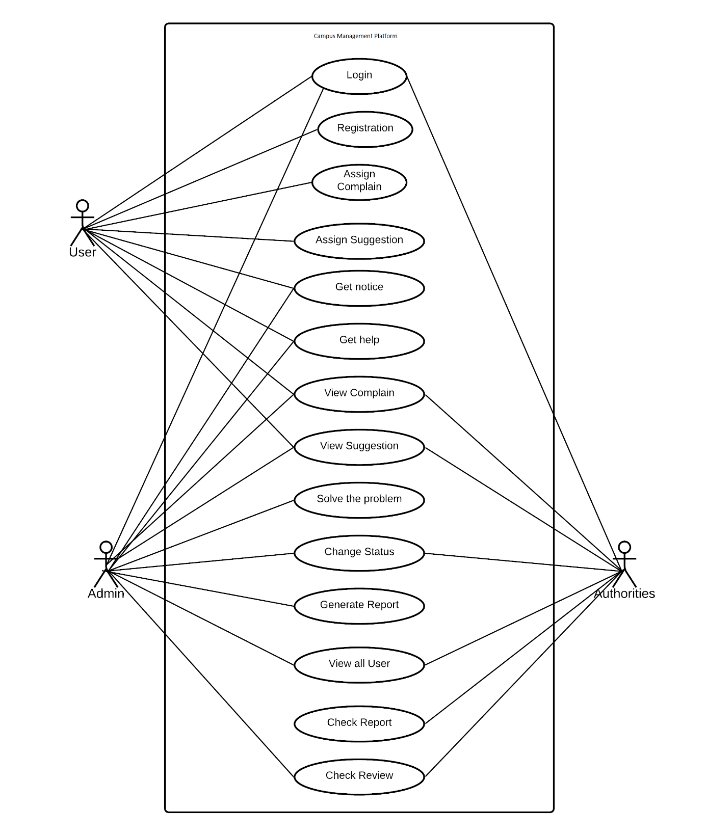

Fig 3.1.1: Use case [2]

#### 3.1.1 Use Case for User

|  |  |  |
| --- | --- | --- |
| **Use Case name** | Login | |
| **Scenario** | User | |
| **Brief Description** | Users must use their own authentic email id to log in.. | |
| **Actor** | Student | |
| **Pre-condition** | Authentic email and login type must be used. | |
| **Post-Condition** | Before logging in, users must confirm their email address. | |
| **Flow of Condition** | User | System |
| * Before logging in, users must validate their email address. | * Verify a genuine email address. * Confirm a valid password * Verify your email address * Allow access to the system. |
| **Exception Condition** | Give permission for account access. | |

|  |  |  |
| --- | --- | --- |
| **Use Case name** | Registration | |
| **Scenario** | User (Student) Registration to the system | |
| **Brief Description** | Users should register themselves by their own email address. | |
| **Actor** | User (Student) | |
| **Pre-condition** | Must be login in to the system. | |
| **Post-Condition** | Users must confirm registration with email verification | |
| **Flow of Condition** | User | System |
| * Must provide Valid   email. | * Must fill up all required   Field   * Confirm valid email   Address   * Confirm unique email address. * Verify confirm password |
| **Exception Condition** | Get permission to create an account. | |

|  |  |  |
| --- | --- | --- |
| **Use Case name** | Assign Suggestion | |
| **Scenario** | Users (Student)can create a suggestion if any problem occurs in campus | |
| **Brief Description** | Users should assign a valid suggestion, what admin should change | |
| **Actor** | User (Student) | |
| **Pre-condition** | Must be login in to the system**.** | |
| **Post-Condition** | Users must confirm the suggestion will be a big change for the campus. | |
| **Flow of Condition** | User | System |
| * Must provide Valid   reason. | * Must fill up all required   Field   * Make sure the reason is valid. |
| **Exception Condition** | Get permission to add a suggestion to the system. | |

|  |  |  |
| --- | --- | --- |
| **Use Case name** | View Complain | |
| **Scenario** | Users (Student) can check their added complain list on the system. | |
| **Brief Description** | Users can view their complain status, and added complain list. | |
| **Actor** | User (Student) | |
| **Pre-condition** | Must be login in to the system | |
| **Post-Condition** | Users must be at least one complain in our system. | |
| **Flow of Condition** | User | System |
| * Must add a complaint before to check the complaint list. * Must add valid information | * Provide specific User’s complaint list from system |
| **Exception Condition** | View complaint list of users. | |

|  |  |  |
| --- | --- | --- |
| **Use Case name** | View Suggestion | |
| **Scenario** | Users (Student) can check their added Suggestion list on the system. | |
| **Brief Description** | Users can view their suggestion status, and added suggestion list. | |
| **Actor** | User (Student) | |
| **Pre-condition** | Must be login in to the system | |
| **Post-Condition** | Users must be at least one suggestion in our system. | |
| **Flow of Condition** | User | System |
| * Must add a suggestion before to check the suggestion list. * Must add valid information | * Provide specific User’s suggestion list from system |
| **Exception Condition** | View suggestion list of users. | |

|  |  |  |
| --- | --- | --- |
| **Use Case name** | View Notice Board | |
| **Scenario** | Users (Student) can check notice list on the system. | |
| **Brief Description** | Users can view university any published notice immediately. | |
| **Actor** | User (Student) | |
| **Pre-condition** | Must be login in to the system | |
| **Post-Condition** | Users should check all notice board. | |
| **Flow of Condition** | User | System |
| * Must check all notice in notice board. | * Provide specific User’s notice list from system. |
| **Exception Condition** | View notice list of users. | |

|  |  |  |
| --- | --- | --- |
| **Use Case name** | Get help | |
| **Scenario** | Users (Student) can get help on the system. | |
| **Brief Description** | Users can get help by chat with helpline. | |
| **Actor** | User (Student) | |
| **Pre-condition** | Must be login in to the system | |
| **Post-Condition** | Users will chat first with helpline. | |
| **Flow of Condition** | User | System |
| * User will message first | * Provide specific User’s solution by helpline. |
| **Exception Condition** | Get help from helpline. | |

### 3.1.2 Use Case for Admin

|  |  |  |
| --- | --- | --- |
| **Use Case name** | Login | |
| **Scenario** | Admin logged on to the system | |
| **Brief Description** | Admin have a specific account defined by system, then he will be able to access the system | |
| **Actor** | Admin | |
| **Pre-condition** | Must be use define valid email and password | |
| **Post-Condition** | Admin must have power to use system. | |
| **Flow of Condition** | Admin | System |
| * Admin must have power to use system | * Confirm valid email address. * Fetch user’s data. |
| **Exception Condition** | Access to manage accounts and others access. | |

|  |  |  |
| --- | --- | --- |
| **Use Case name** | View Complain | |
| **Scenario** | Admin will show the user Complain list. | |
| **Brief Description** | Admin will see the complaint list that provide by user. | |
| **Actor** | Admin | |
| **Pre-condition** | Admin must be login his/her Admin Dashboard. | |
| **Post-Condition** | Admin must have a good ethics. | |
| **Flow of Condition** | Admin | System |
| * Check all data * Isolate suspicious data. | * Fetch user’s complain list. |
| **Exception Condition** | Access to see user’s complain list. | |

|  |  |  |
| --- | --- | --- |
| **Use Case name** | View Suggestion | |
| **Scenario** | Admin will show the user suggestion list. | |
| **Brief Description** | Admin will see the suggestion list that provide by user. | |
| **Actor** | Admin | |
| **Pre-condition** | Admin must be login his/her Admin Dashboard. | |
| **Post-Condition** | Admin must have a good ethics. | |
| **Flow of Condition** | Admin | System |
| * Check all data * Isolate suspicious data. | * Fetch user’s suggestion list. |
| **Exception Condition** | Access to see user’s Suggestion list. | |

|  |  |  |
| --- | --- | --- |
| **Use Case name** | Solve the problem | |
| **Scenario** | Admin will solve the problem. | |
| **Brief Description** | Admin will solve the problem which is complain by user physically | |
| **Actor** | Admin | |
| **Pre-condition** | Admin must be login his/her Admin Dashboard. | |
| **Post-Condition** | Admin must have a good ethics. | |
| **Flow of Condition** | Admin | System |
| * Solve the problem which is in list. | * Fetch user’s complain list. |
| **Exception Condition** | Admin will solve the problem. | |

|  |  |  |
| --- | --- | --- |
| **Use Case name** | Approve Complain/Suggestion | |
| **Scenario** | Admin will approve the valid complain/suggestion | |
| **Brief Description** | Admin will check the complaint was valid reason or not, then he/she will accept the complain and try to solve it. | |
| **Actor** | Admin | |
| **Pre-condition** | Admin must be login his/her Admin Dashboard. | |
| **Post-Condition** | Admin must have power to use system. | |
| **Flow of Condition** | Admin | System |
| * Admin must accept only the valid complain | * Get access to approve the complain. * Fetch user’s data. |
| **Exception Condition** | Access to change the status of approve complain. | |

|  |  |  |
| --- | --- | --- |
| **Use Case name** | Solve the problem | |
| **Scenario** | Admin will solve the problem. | |
| **Brief Description** | Admin will solve the problem which is complain by user physically | |
| **Actor** | Admin | |
| **Pre-condition** | Admin must be login his/her Admin Dashboard. | |
| **Post-Condition** | Admin must have a good ethics. | |
| **Flow of Condition** | Admin | System |
| * Solve the problem which is in list. | * Fetch user’s complain list. |
| **Exception Condition** | Admin will solve the problem. | |

|  |  |  |
| --- | --- | --- |
| **Use Case name** | Generate Report | |
| **Scenario** | Admin will send a report which complain is accept by him. | |
| **Brief Description** | Admin will mail the authority which complain was accepted. | |
| **Actor** | Admin | |
| **Pre-condition** | Admin must be login his/her Admin Dashboard. | |
| **Post-Condition** | Admin should have a strong internet. | |
| **Flow of Condition** | Admin | System |
| * Send a mail to authority. | * Send the mail immediately to the authorities. |
| **Exception Condition** | Admin will success to mail a report to the authority. | |

|  |  |  |
| --- | --- | --- |
| **Use Case name** | View User List | |
| **Scenario** | Admin will view all user details | |
| **Brief Description** | Admin will check all user details and manage. | |
| **Actor** | Admin | |
| **Pre-condition** | Admin must be login his/her Admin Dashboard. | |
| **Post-Condition** | Admin should have a strong ethics. | |
| **Flow of Condition** | Admin | System |
| * Check valid user. | * Fetch user data. * Manage operation. |
| **Exception Condition** | Admin will view and manage user data. | |

### 3.1.3 Use Case for Authority

|  |  |  |
| --- | --- | --- |
| **Use Case name** | Login | |
| **Scenario** | Authority logged on to the system | |
| **Brief Description** | Authority has a specific account defined by system, then he will be able to access the system | |
| **Actor** | Authority | |
| **Pre-condition** | Must be use define valid email and password | |
| **Post-Condition** | Authority must have power to use system. | |
| **Flow of Condition** | Authority | System |
| * Authority must have power to use system | * Confirm valid email address. * Fetch user’s data. |
| **Exception Condition** | Access to manage accounts and others access. | |

|  |  |  |
| --- | --- | --- |
| **Use Case name** | View Complain | |
| **Scenario** | Authority will show the user Complain list and manage. | |
| **Brief Description** | Authority will see the complaint list that provide by user. | |
| **Actor** | Authority | |
| **Pre-condition** | Authority must be login his/her Admin Dashboard. | |
| **Post-Condition** | Authority must have a good ethics. | |
| **Flow of Condition** | Authority | System |
| * Check all data * Isolate suspicious data. | * Fetch user’s complain list. |
| **Exception Condition** | Access to see user’s complain list. | |

|  |  |  |
| --- | --- | --- |
| **Use Case name** | View Suggestion | |
| **Scenario** | Authority will show the user suggestion list. | |
| **Brief Description** | Authority will see the suggestion list that provide by user. | |
| **Actor** | Authority | |
| **Pre-condition** | Authority must be login his/her Admin Dashboard. | |
| **Post-Condition** | Authority must have a good ethics. | |
| **Flow of Condition** | Authority | System |
| * Check all data * Isolate suspicious data. | * Fetch user’s suggestion list. |
| **Exception Condition** | Access to see user’s Suggestion list. | |

|  |  |  |
| --- | --- | --- |
| **Use Case name** | Check Report | |
| **Scenario** | Authority will check a report which complain is accept by admin. | |
| **Brief Description** | Authority will check mail the which is accept by admin. | |
| **Actor** | Authority | |
| **Pre-condition** | Authority must be login his/her Admin Dashboard. | |
| **Post-Condition** | Authority should have a strong internet. | |
| **Flow of Condition** | Authority | System |
| * Check the mail send by admin. | * Show the mail immediately to the authorities. |
| **Exception Condition** | Authority will success to check the mail. | |

**3.2 Activity Diagram**

#### 3.2.1 Activity Diagram for User

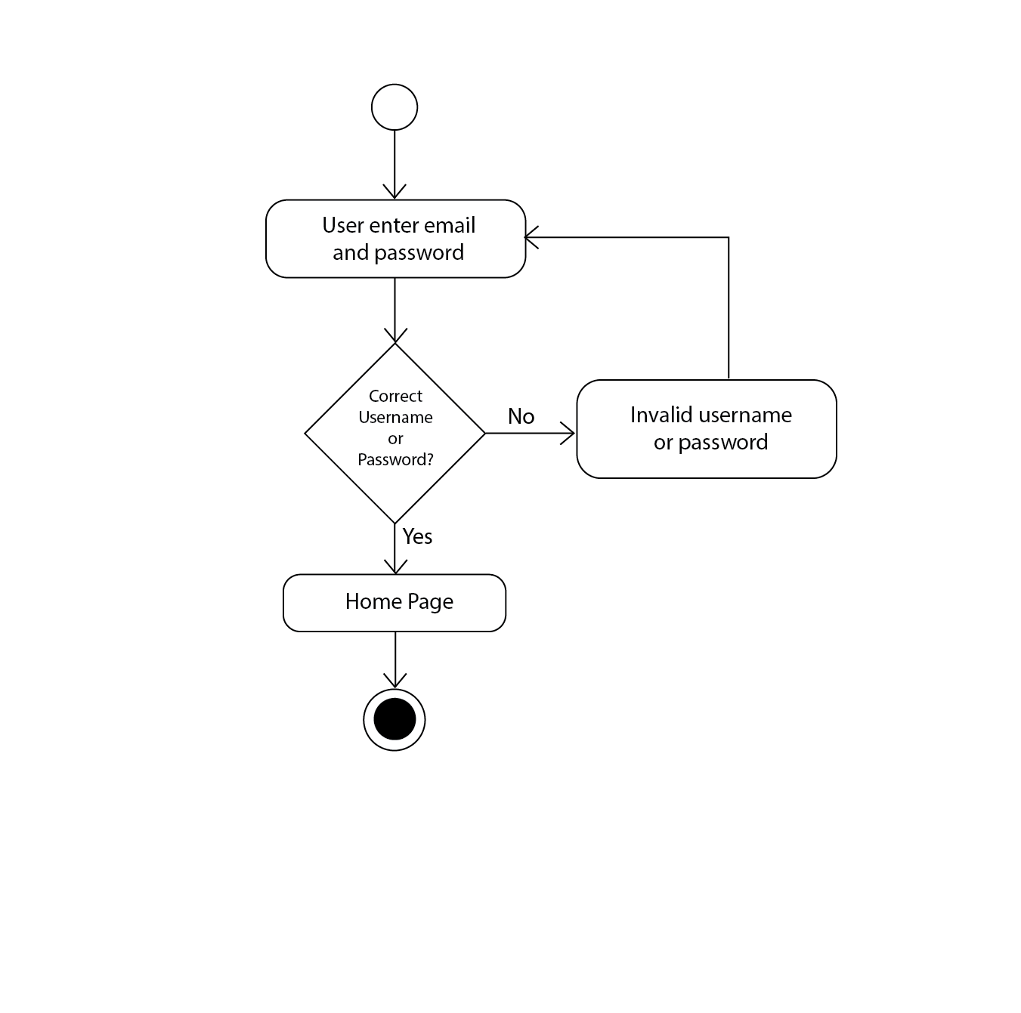

Fig 3.2.1.1 User Login

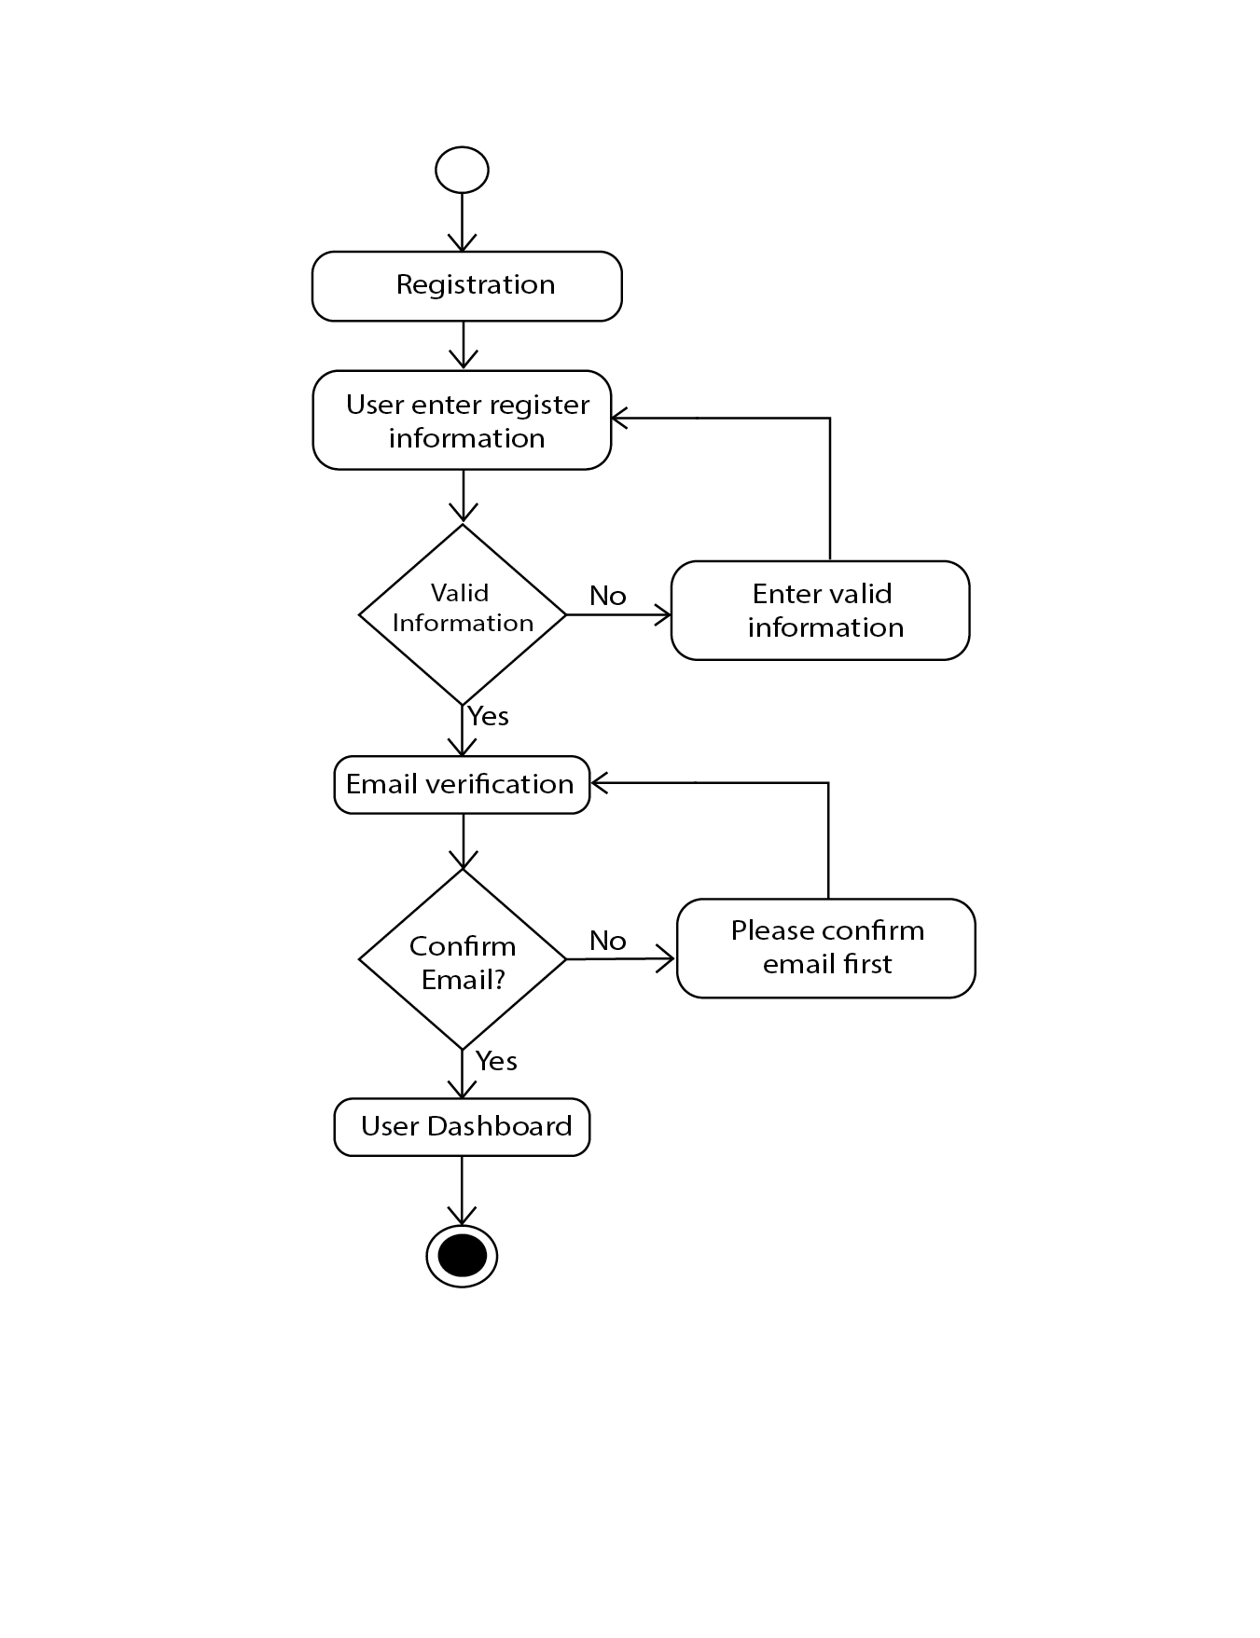

Fig 3.2.1.2 User Registration

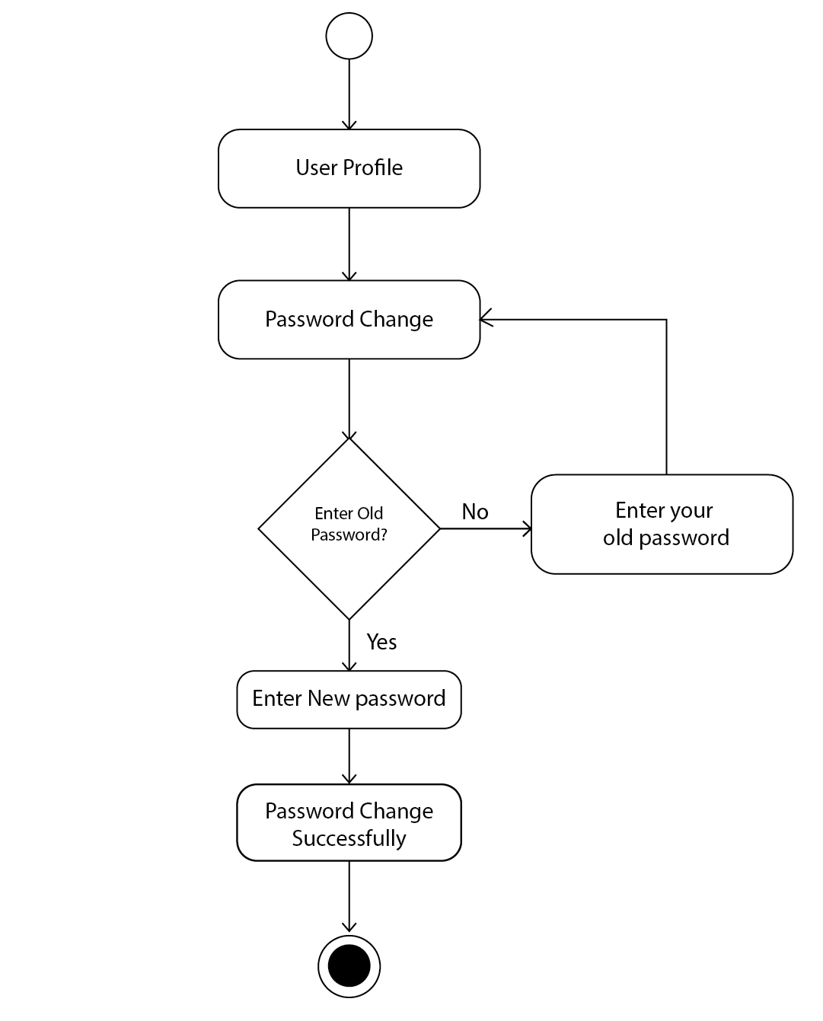

Fig 3.2.1.3 User Password Change

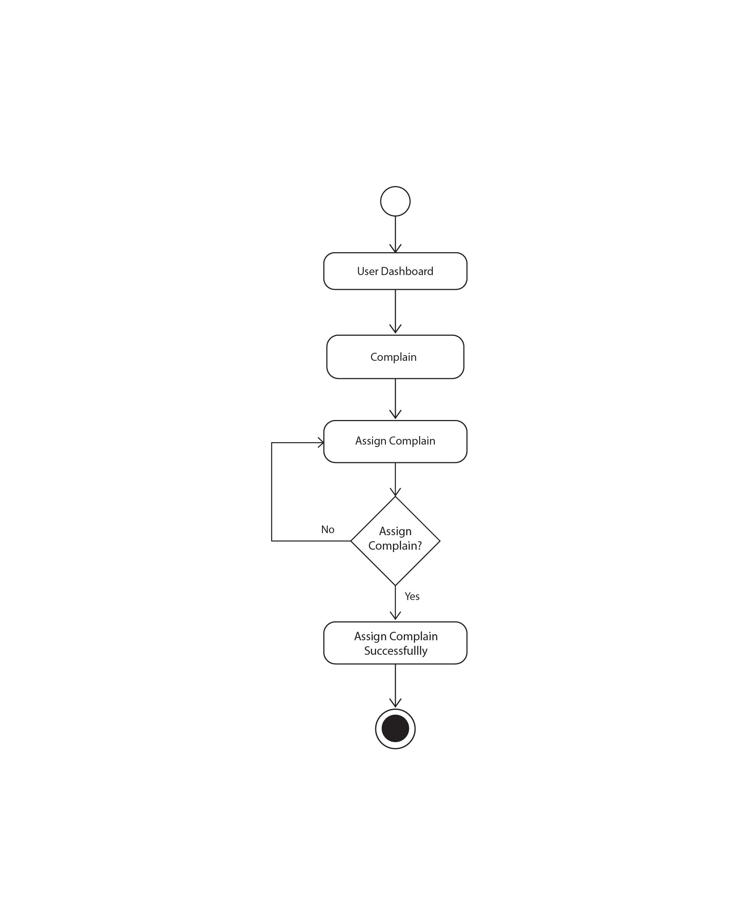

Fig 3.2.1.4 User Assign Complain

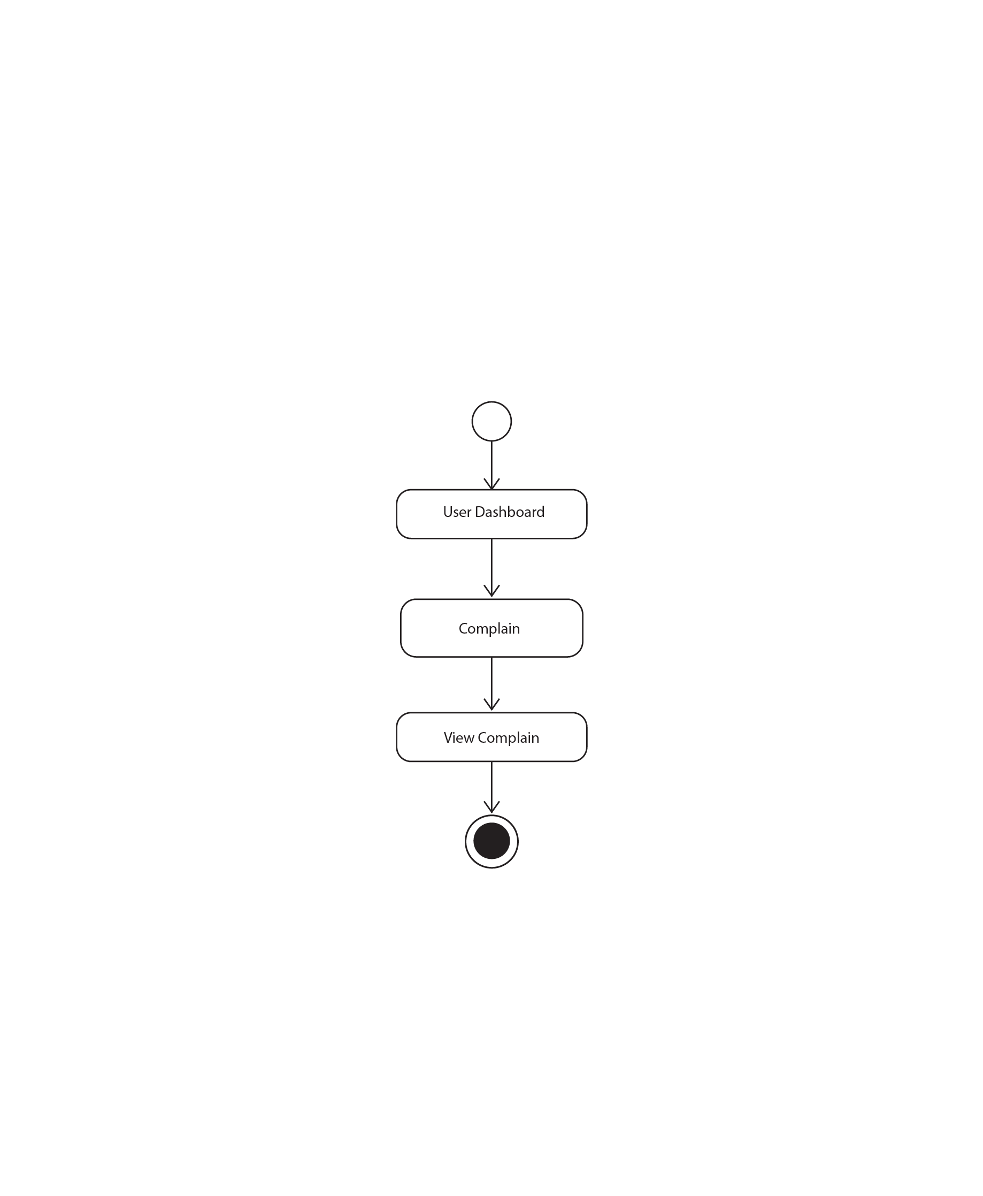

Fig 3.2.1.5 User View Complain

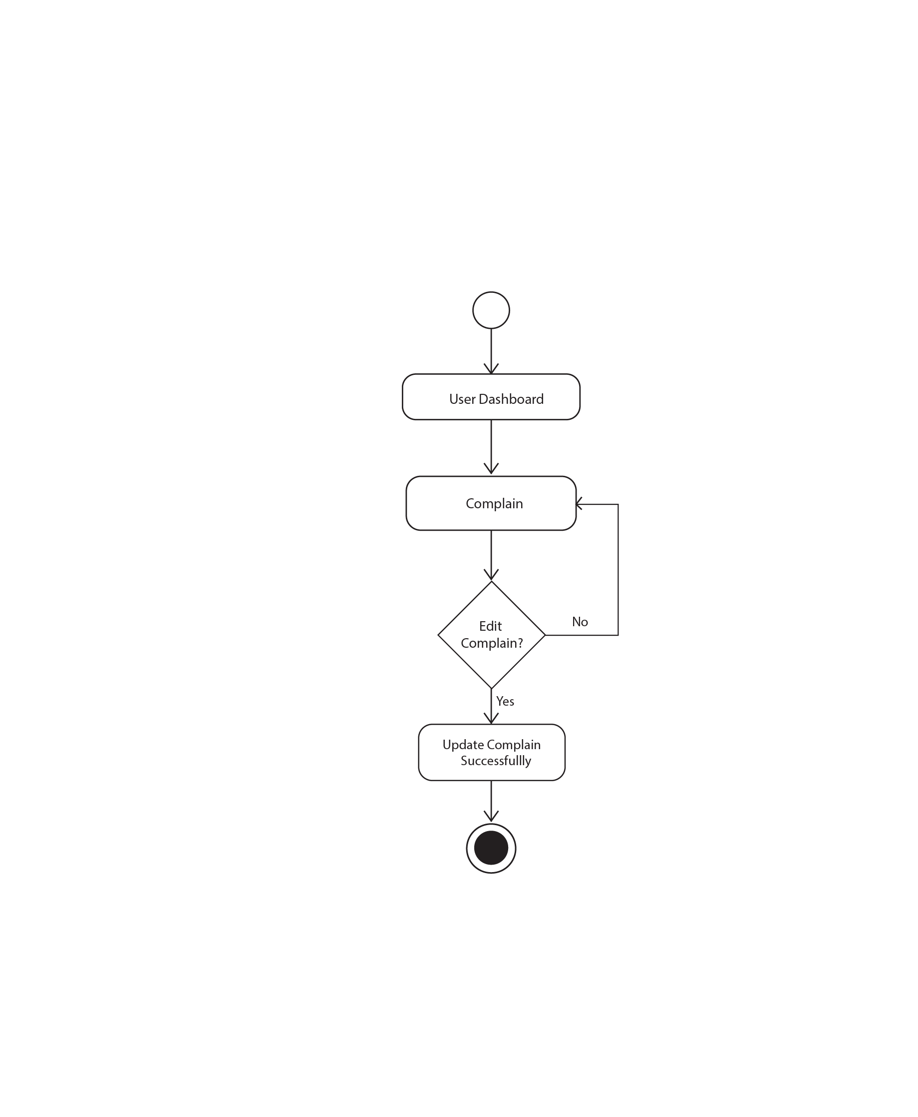

Fig 3.2.1.6 User Edit Complain

.

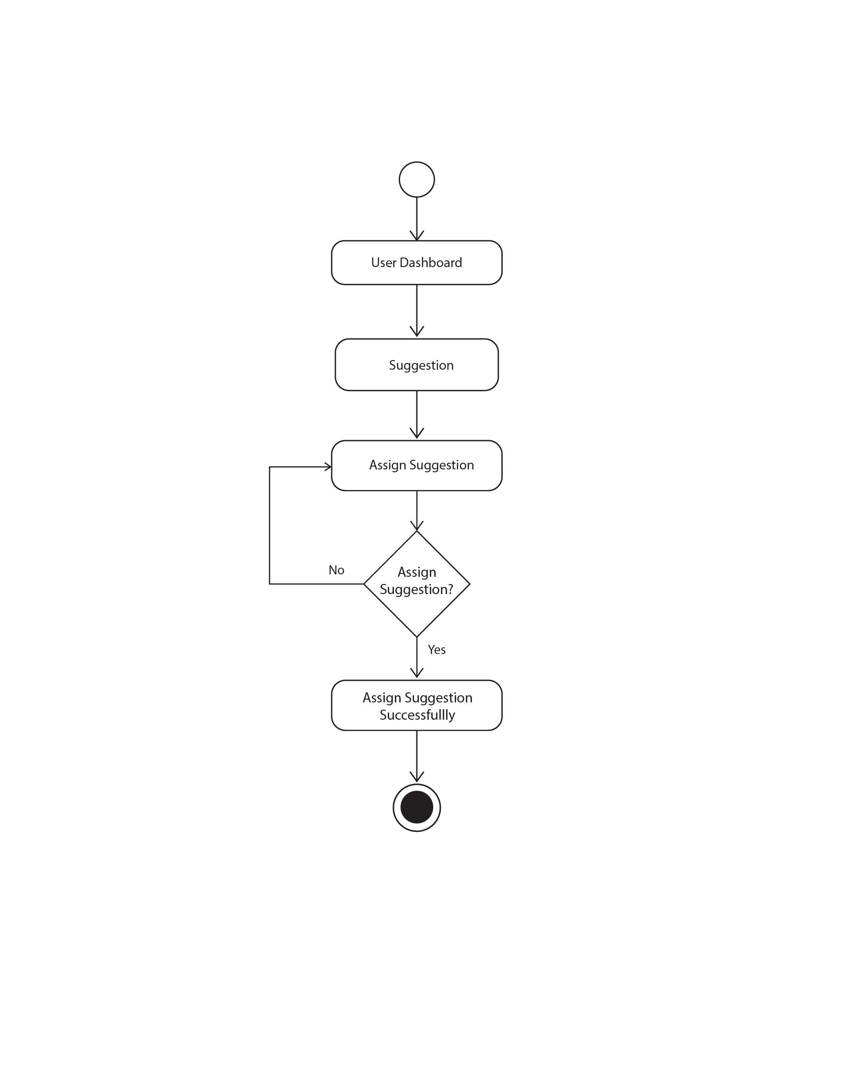

Fig 3.2.1.7 User Assign Suggestion

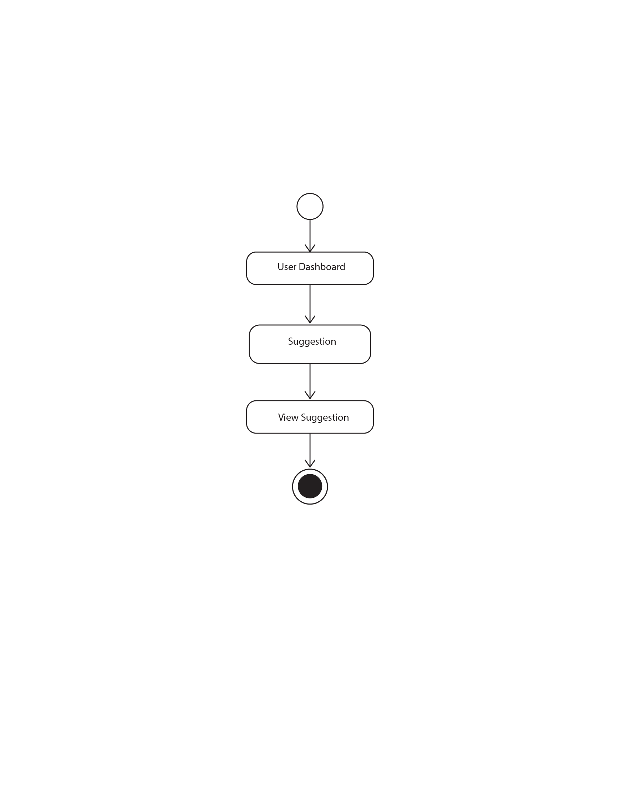

Fig 3.2.1.8 User View Suggestion

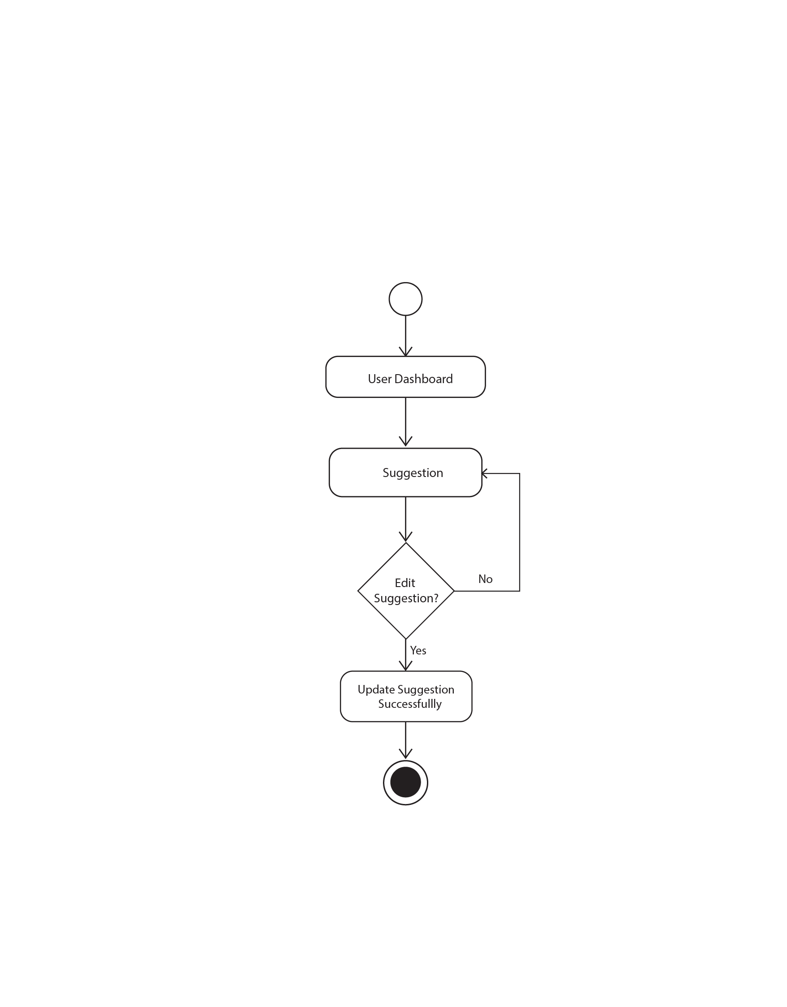

Fig 3.2.1.9 User Edit Suggestion

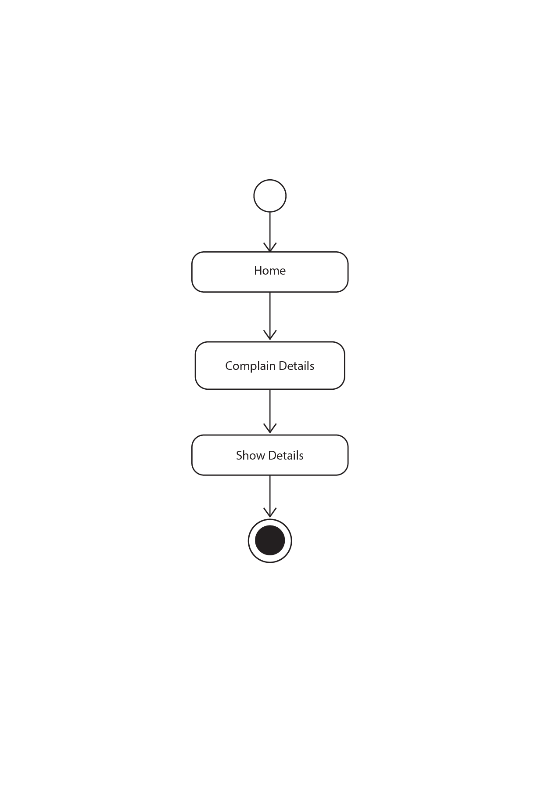

Fig 3.2.1.10 User Complain Details

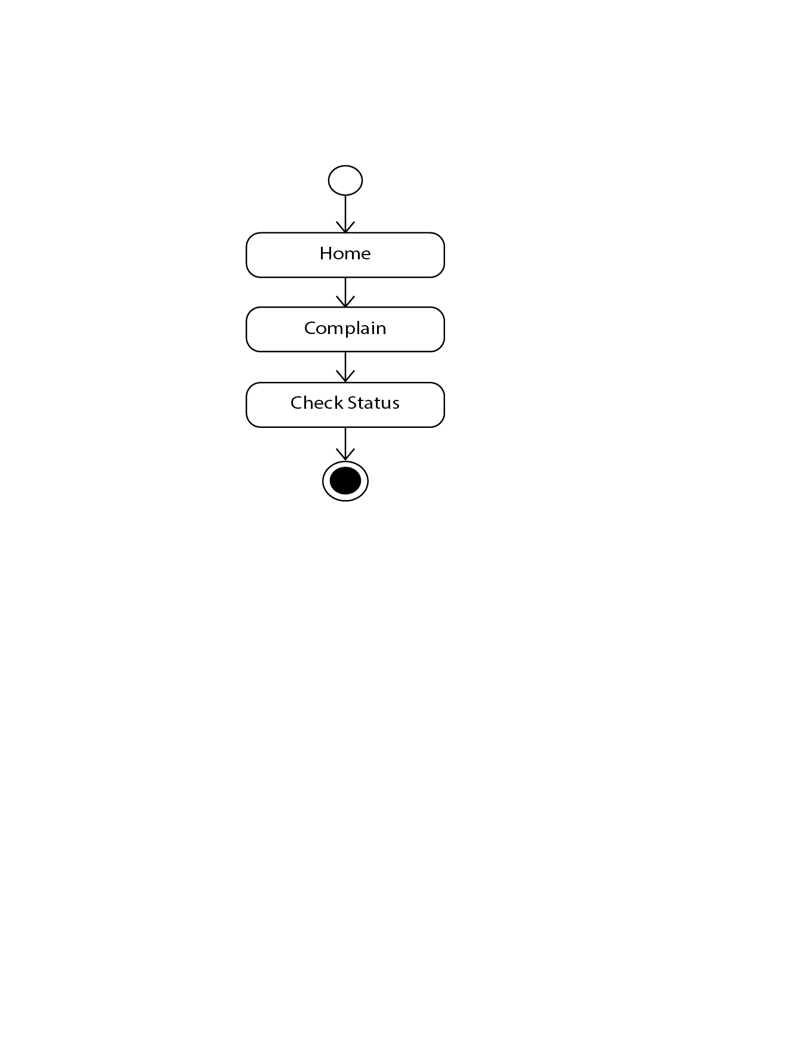

Fig 3.2.1.11 User Complain Status

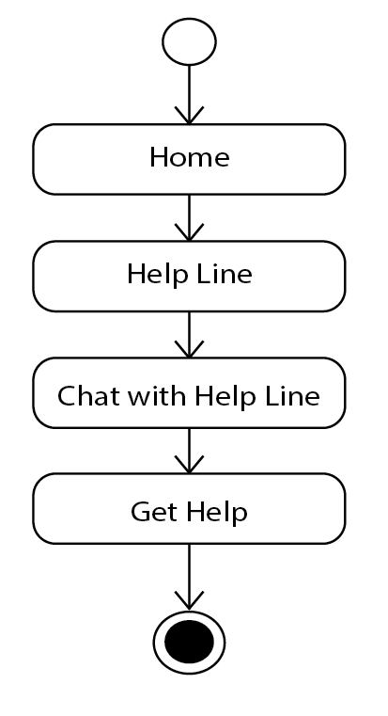

Fig 3.2.1.12 User Get Help

#### 3.2.2 Activity Diagram for Admin

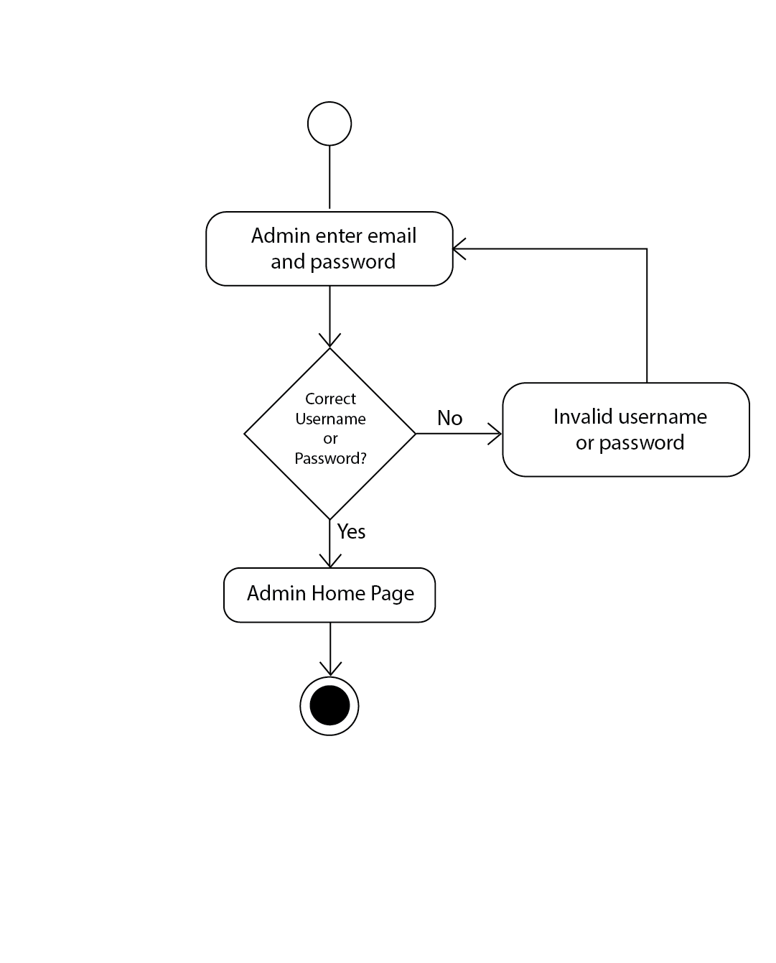

Fig 3.2.2.1 Admin Login

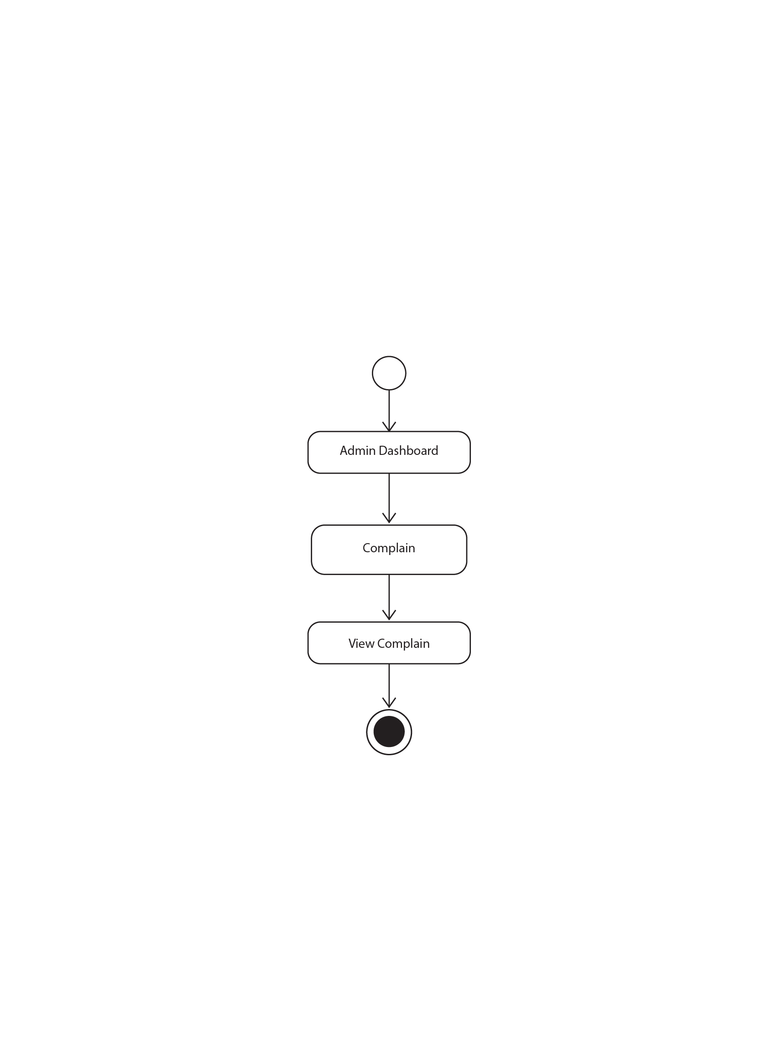

Fig 3.2.2.2 Admin Complain

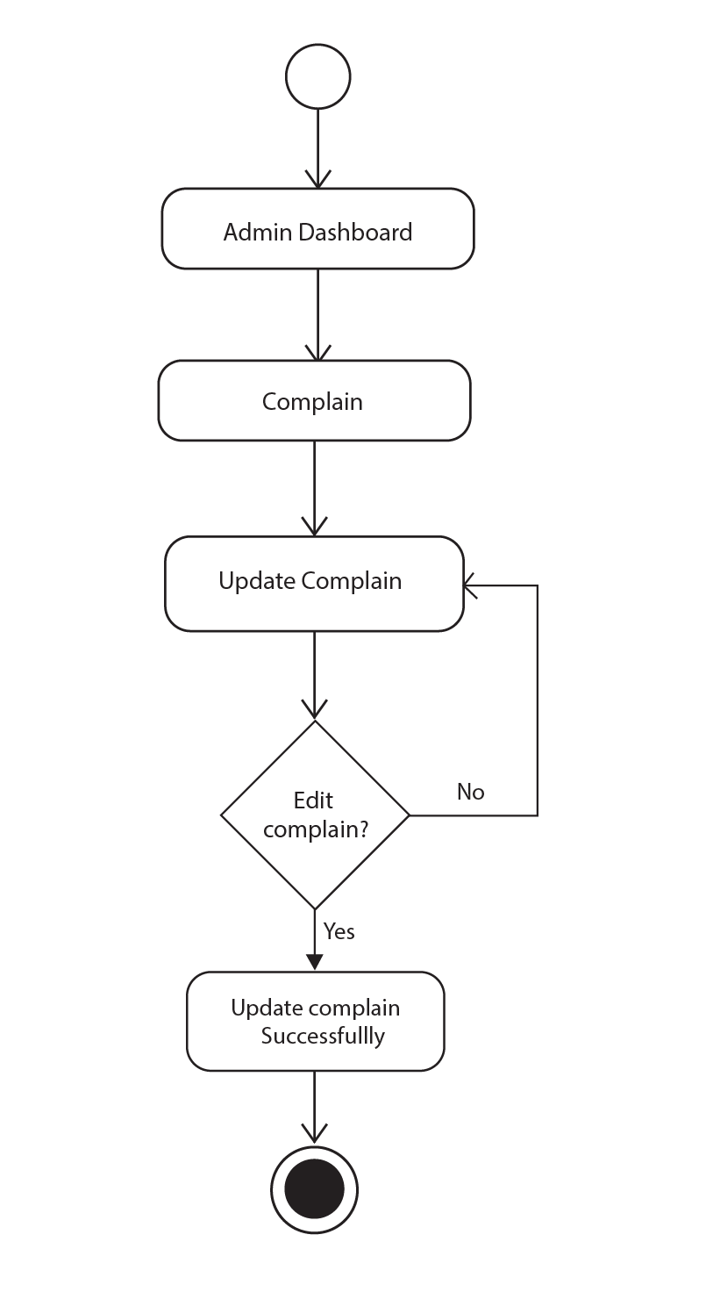

Fig 3.2.2.3 Admin Update Complain

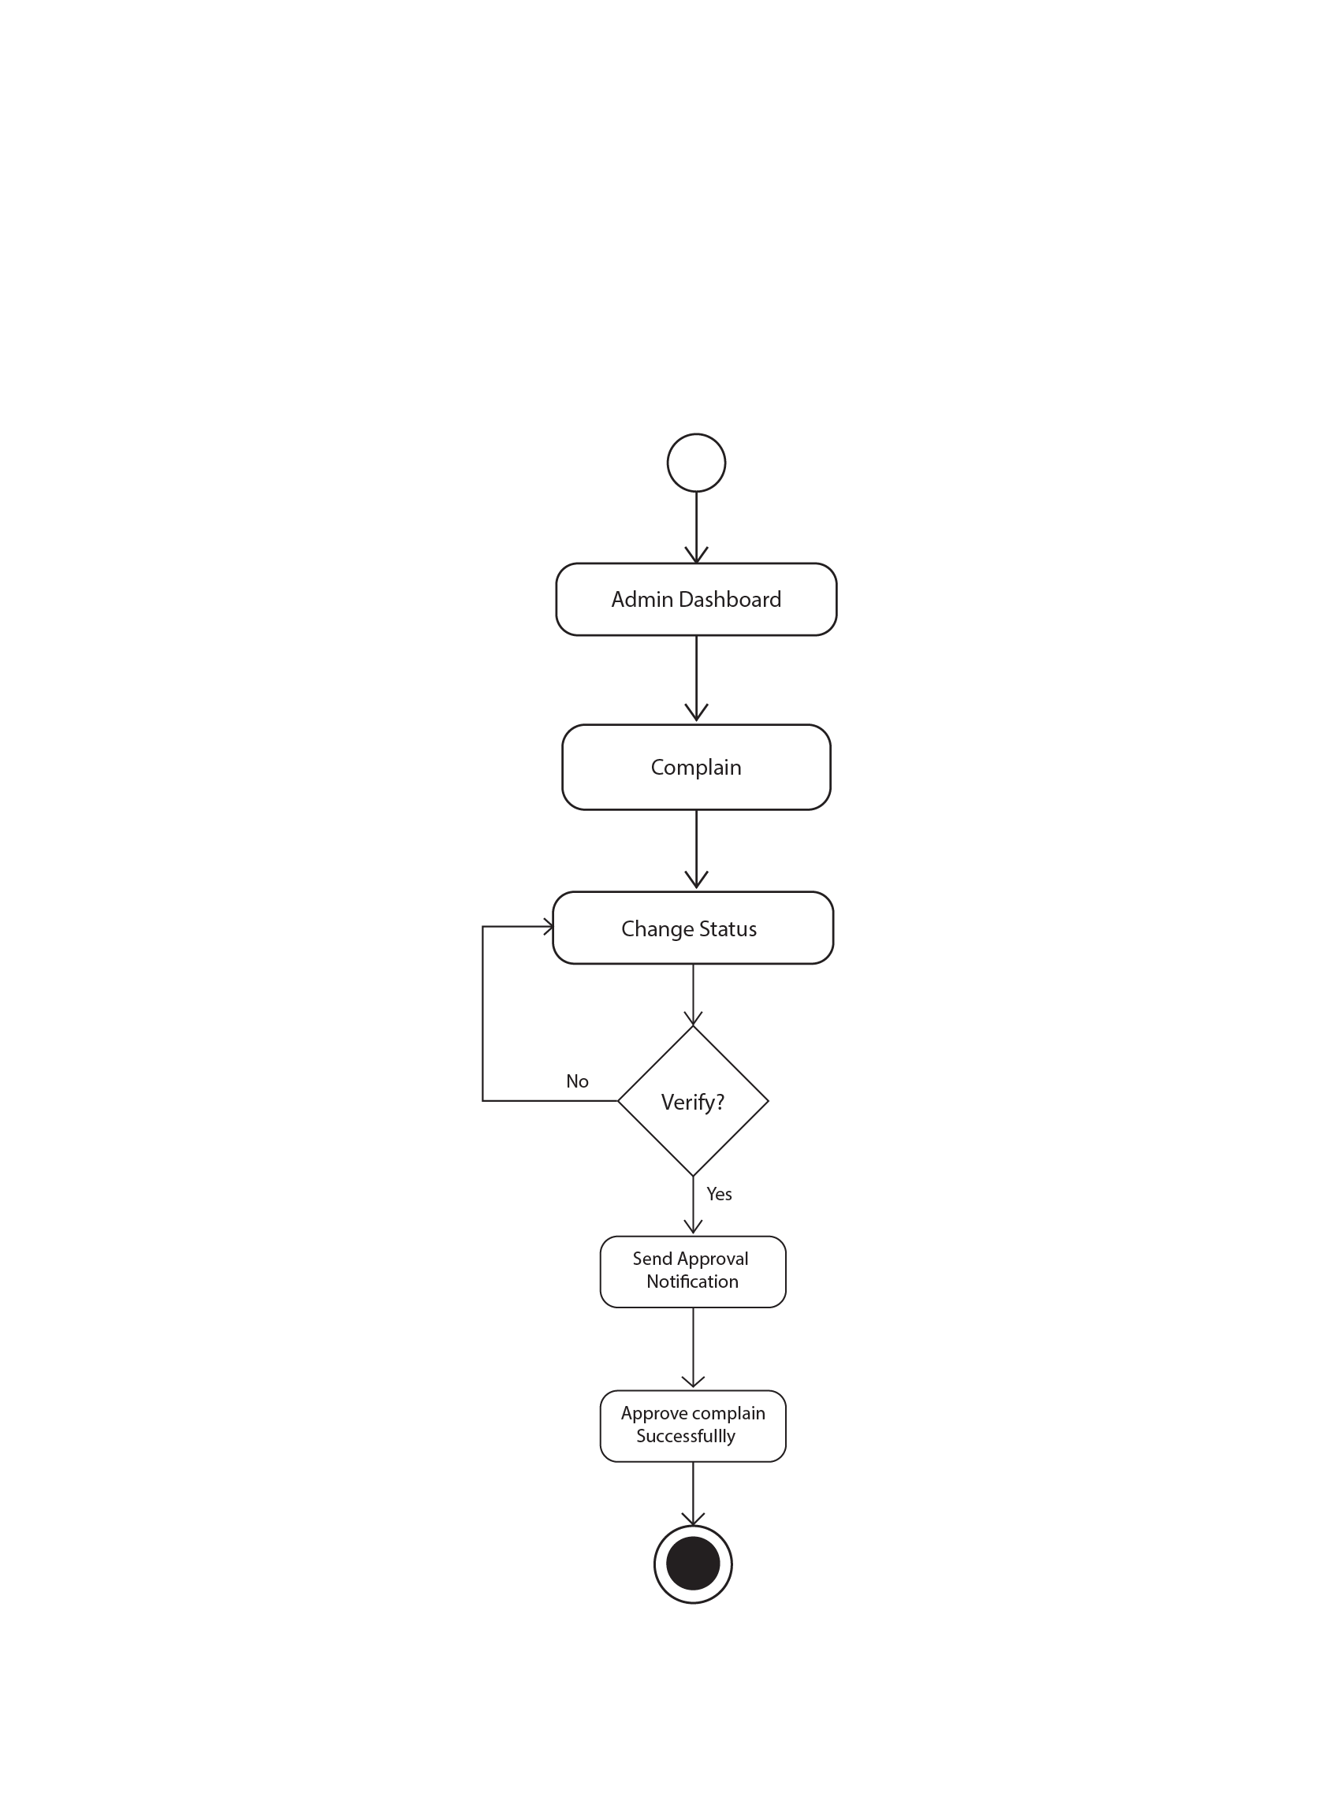

Fig 3.2.2.3 Admin Complain Approve

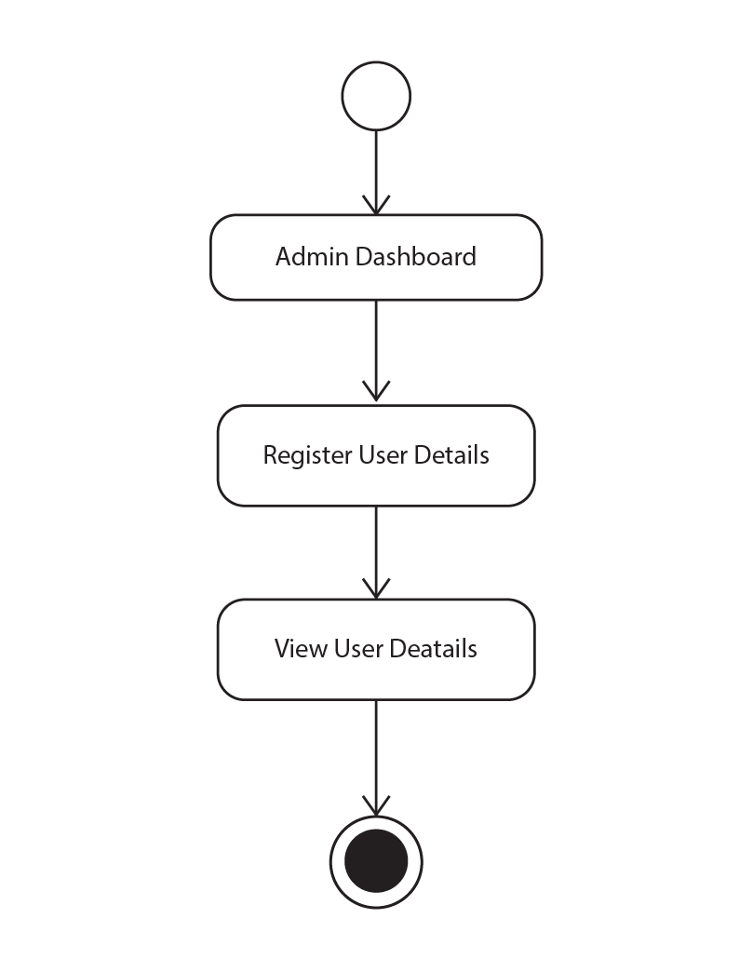

Fig 3.2.2.4 Admin User Details

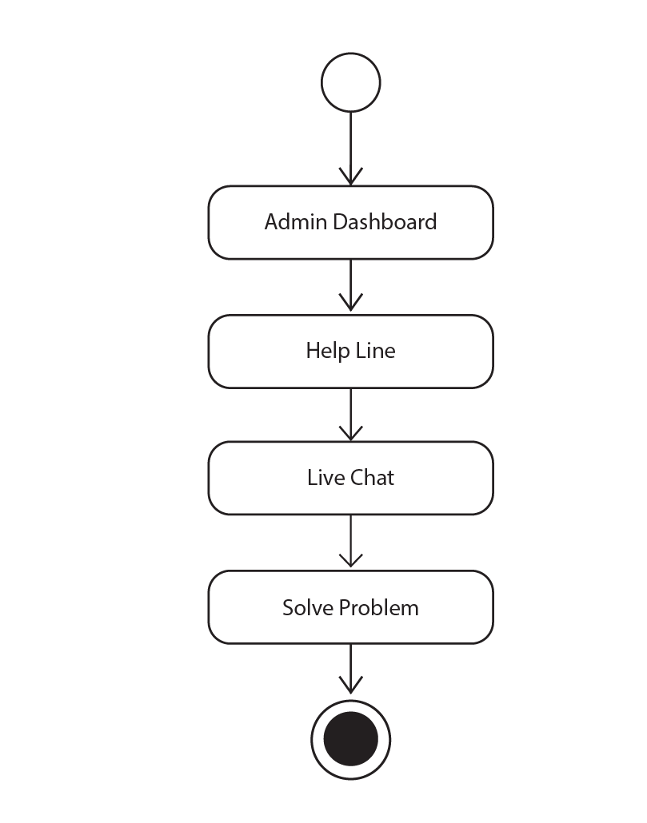

Fig 3.2.2.5 Admin User Help

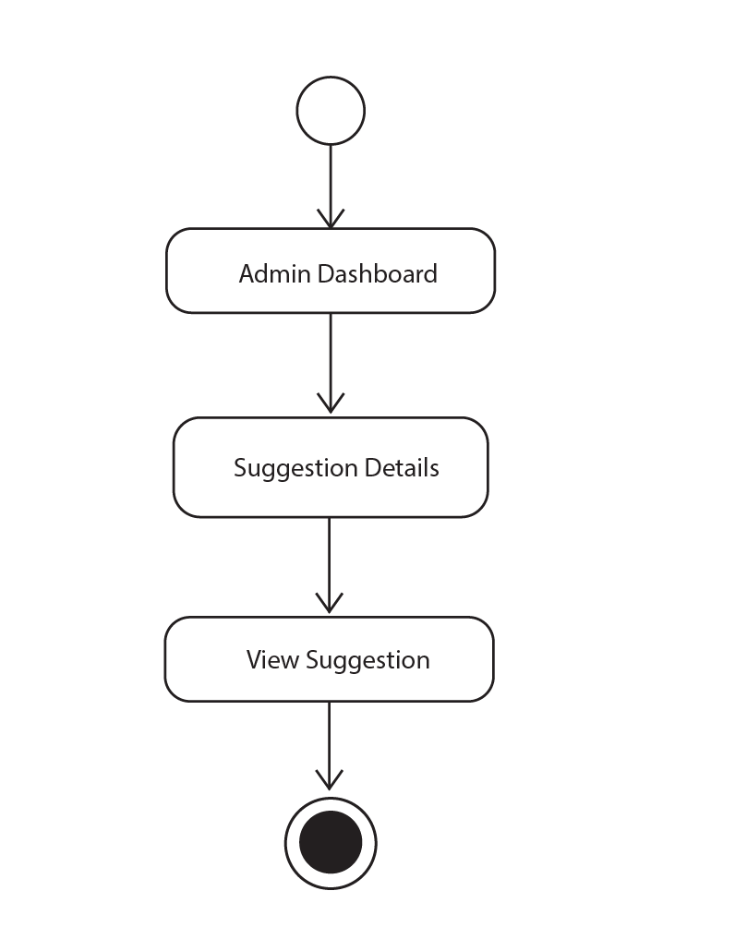

Fig 3.2.2.5 Admin User Suggestion Details

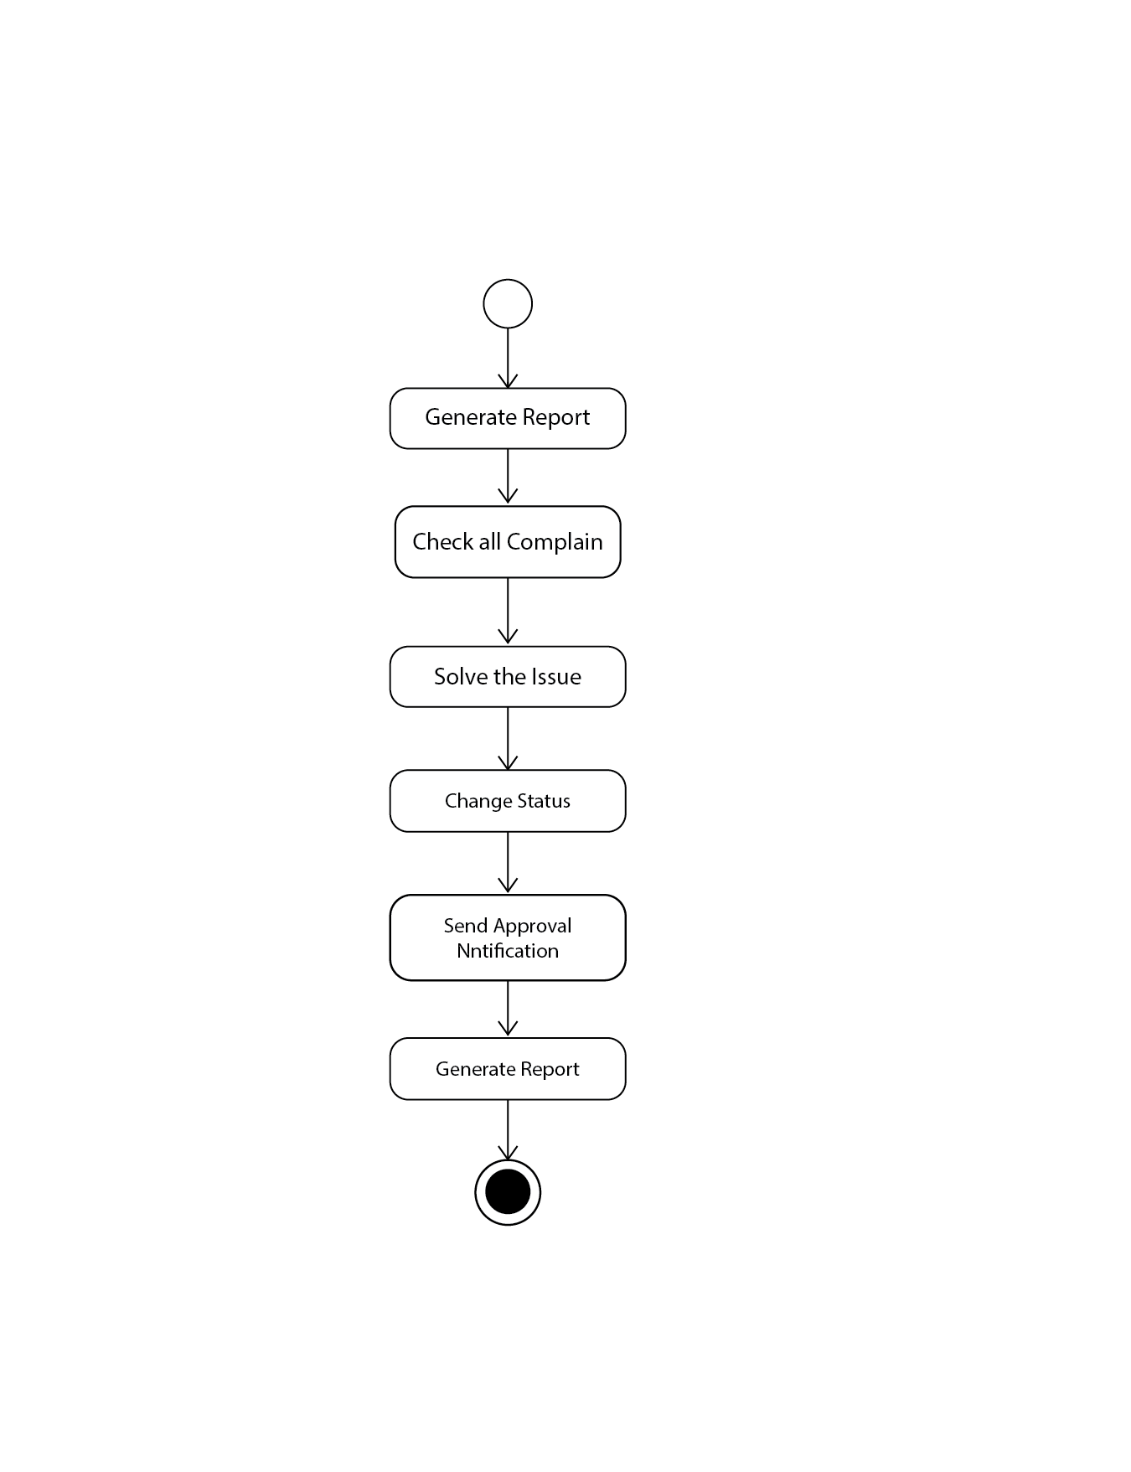

Fig 3.2.2.6 Admin Generate Report

#### 3.2.3 Activity Diagram for Authority

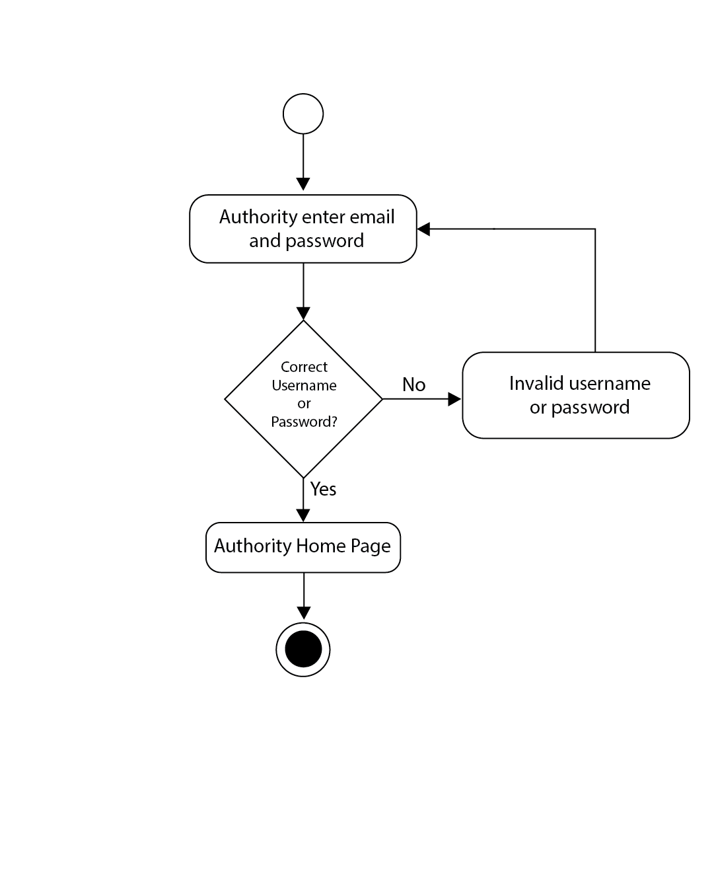

Fig 3.2.3.1 Authority Login

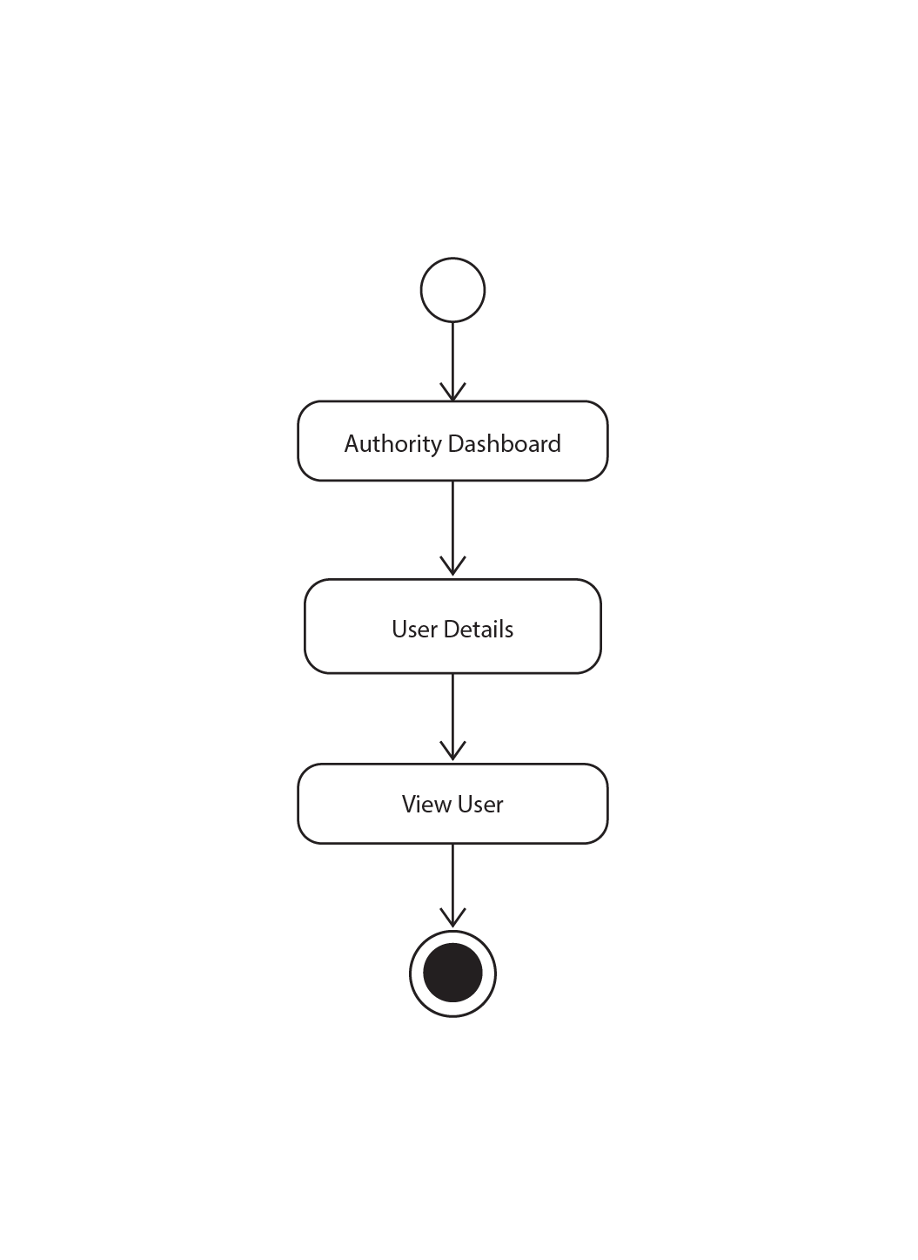

Fig 3.2.3.2 Authority View User

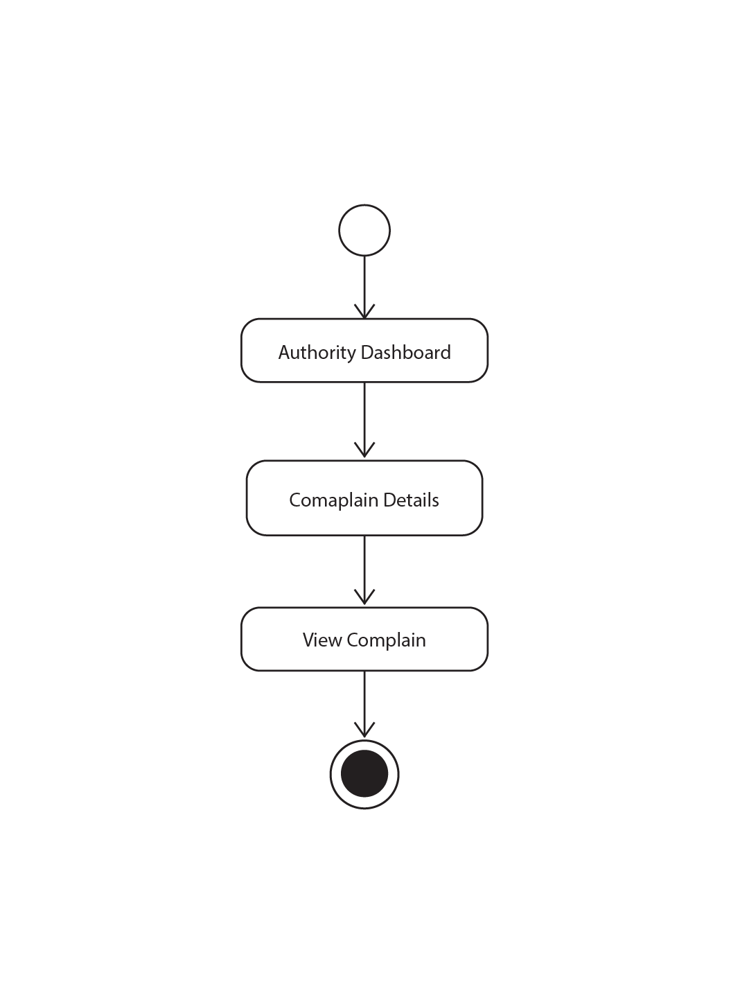

Fig 3.2.3.2 Authority User Complain

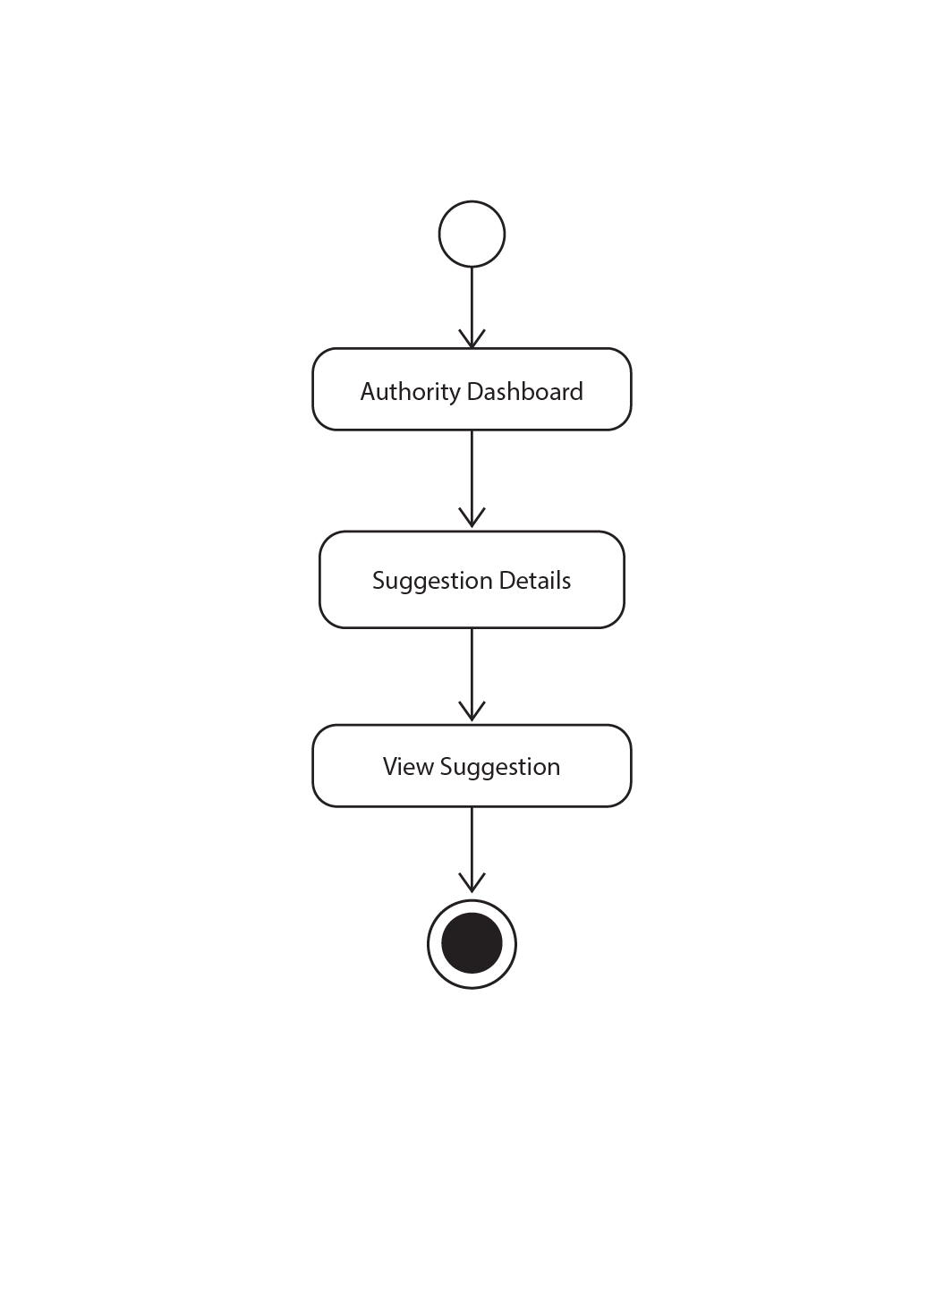

Fig 3.2.3.3 Authority User Suggestion

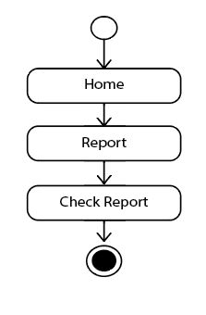

Fig 3.2.3.4 Authority Report check

**3.3 Sequence Diagram**

#### 3.3.1 Sequence Diagram for User

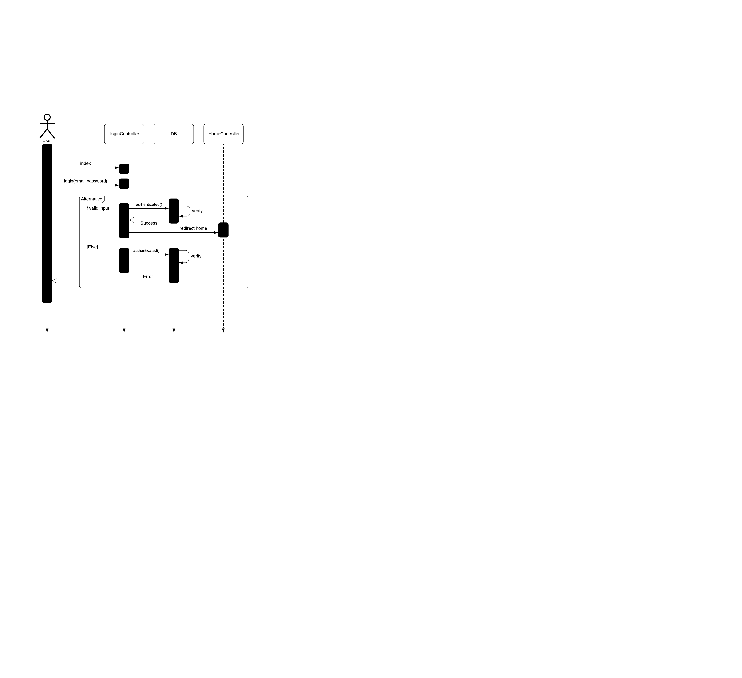

Fig 3.3.1.1 User login

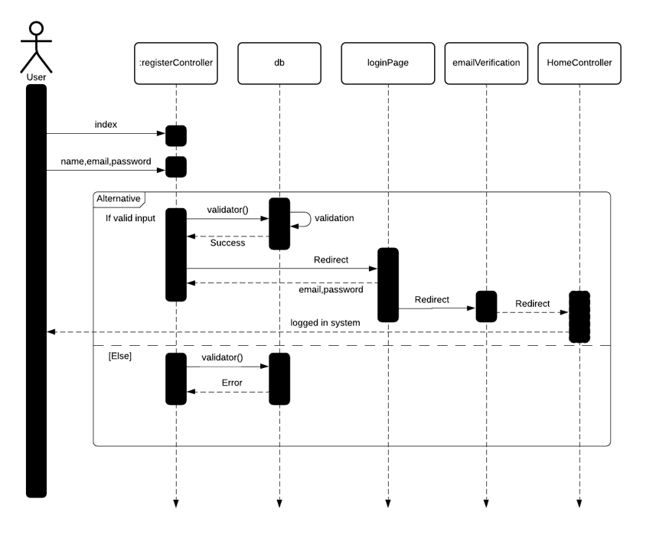

Fig 3.3.1.2 User Registration

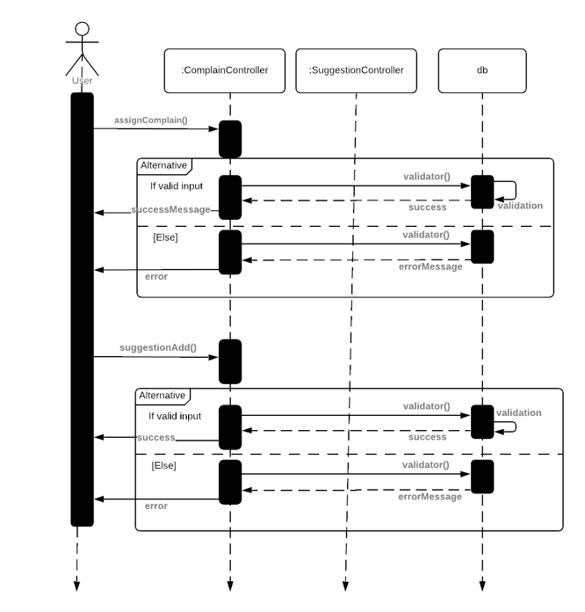

Fig 3.3.1.2 User Complain and Suggestion

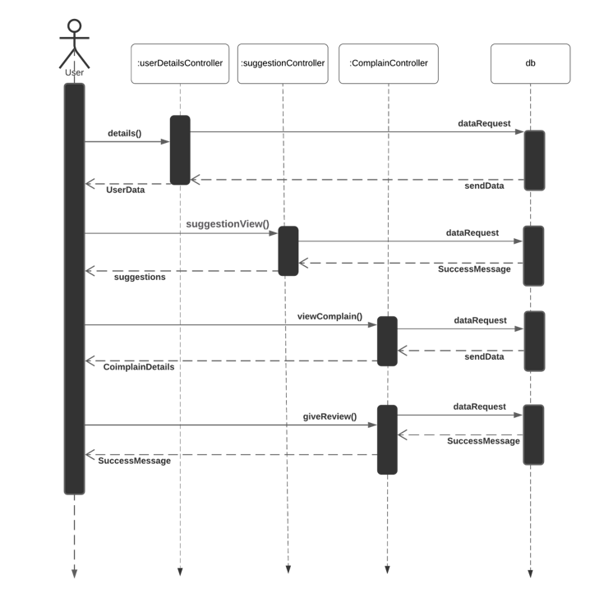

Fig 3.3.1.3 User Main Sequence

#### 3.3.2 Sequence Diagram for Admin

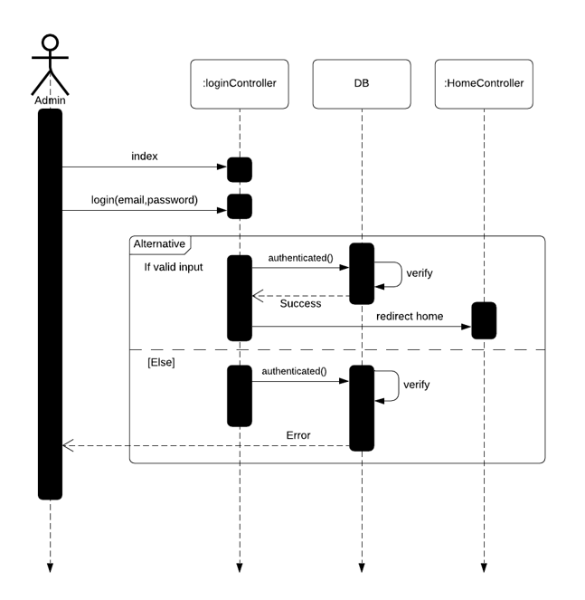

Fig 3.3.2.1 Admin login

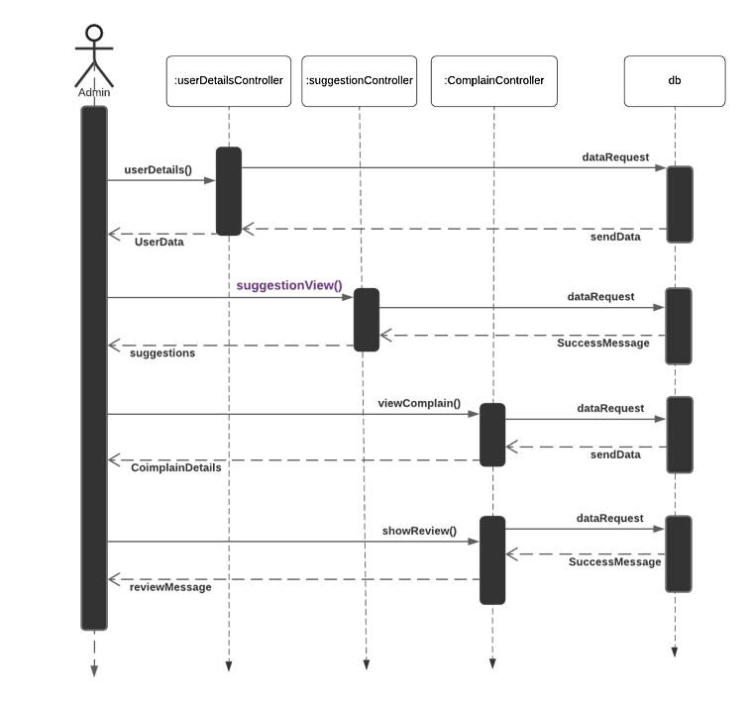

Fig 3.3.2.2 Admin Main Options

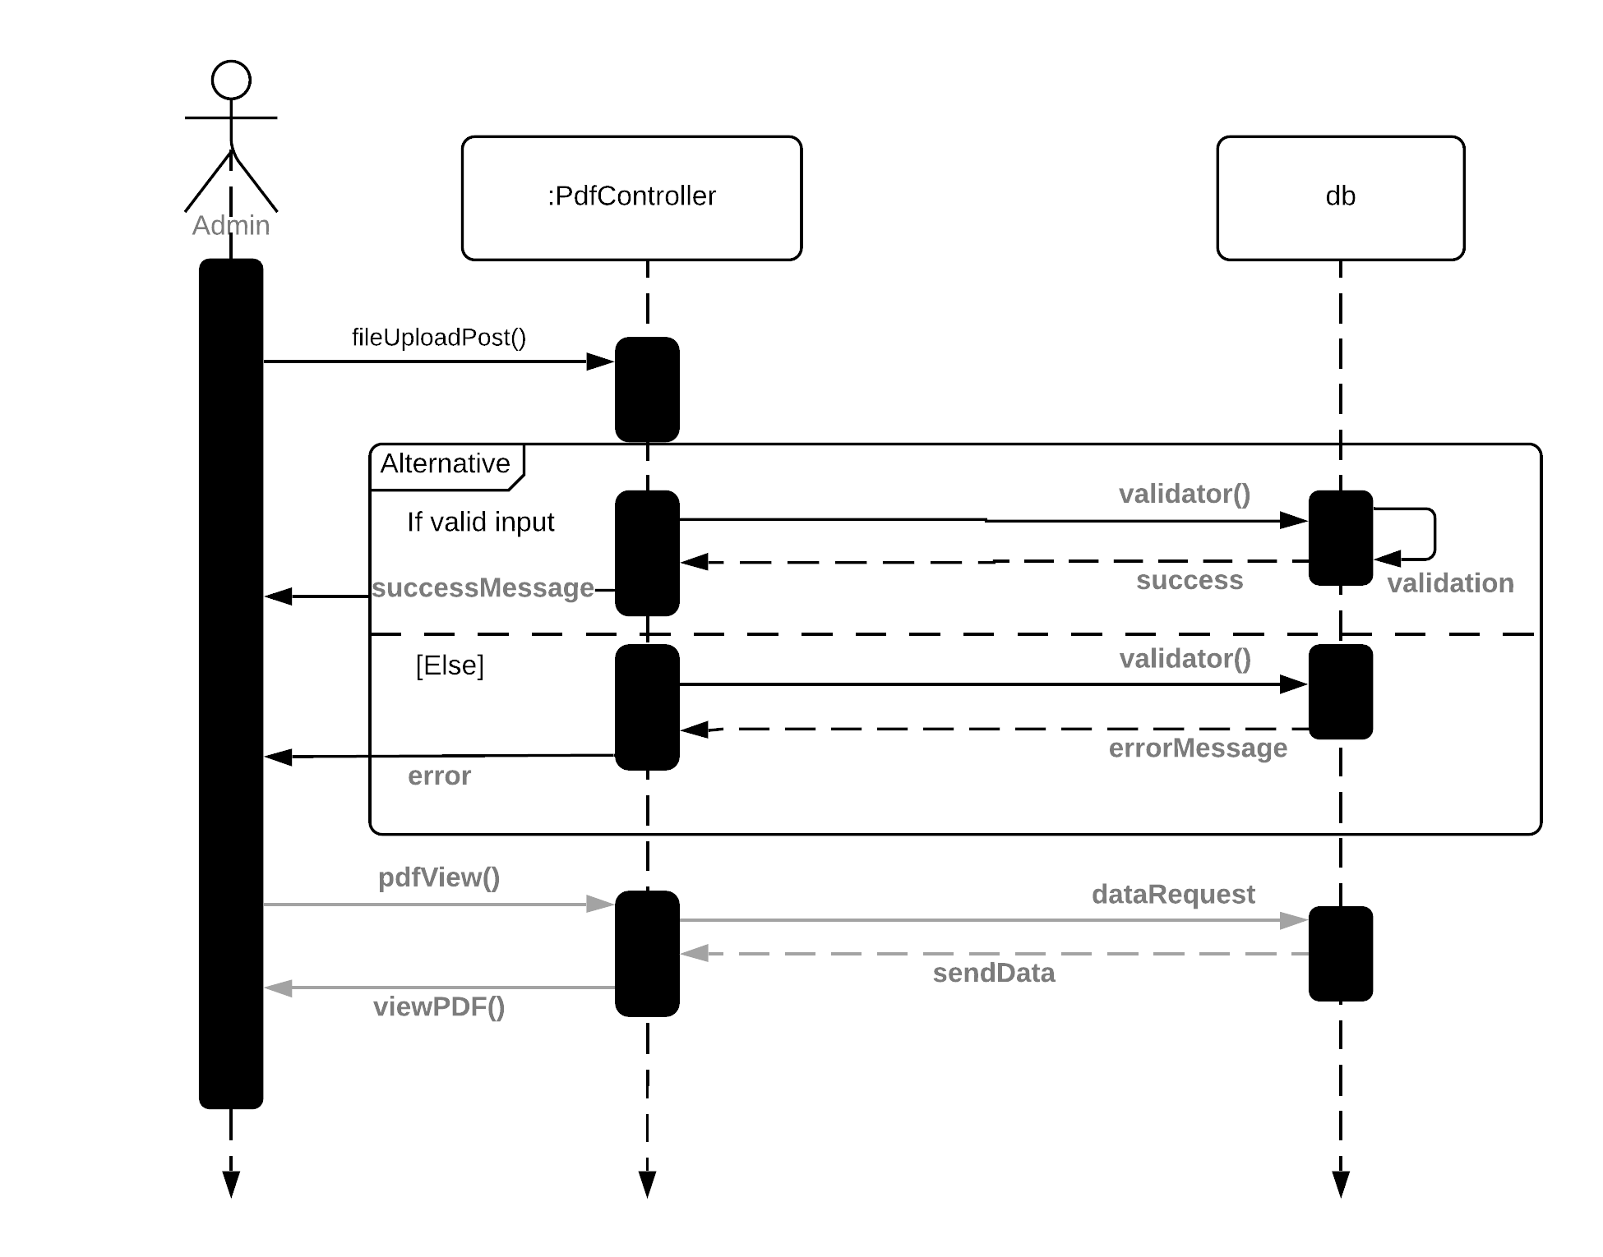

Fig 3.3.2.3 Admin Notice Update

#### 3.3.3 Sequence Diagram for Authority

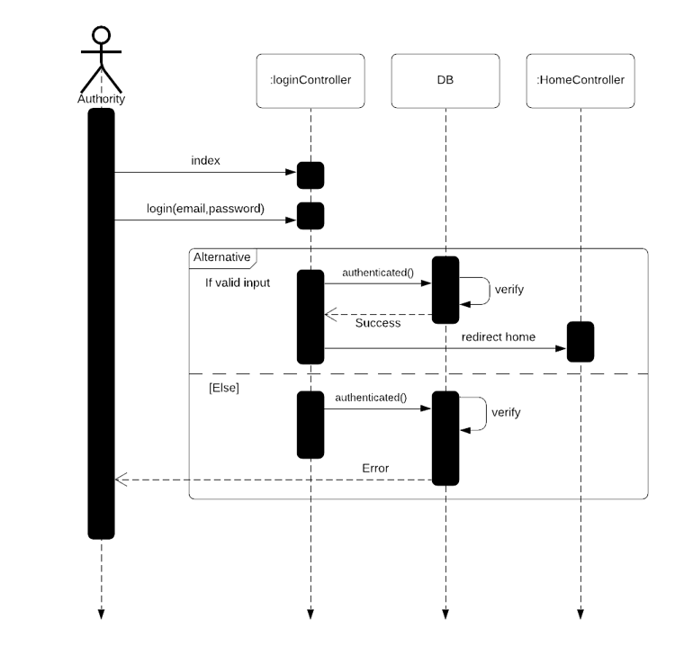

Fig 3.3.3.1 Authority Login

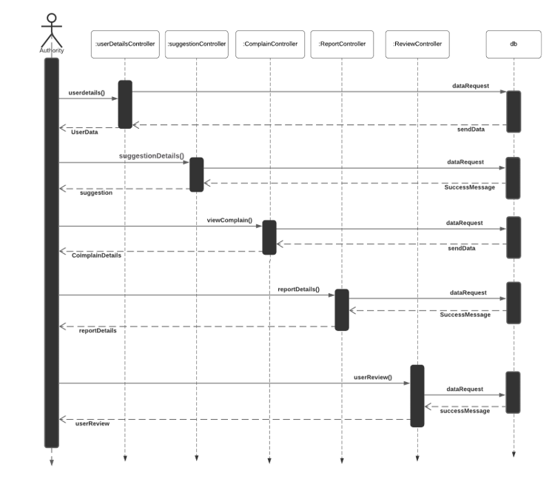

Fig 3.3.3.2 Authority Main Options

### 3.4 ERD Diagram

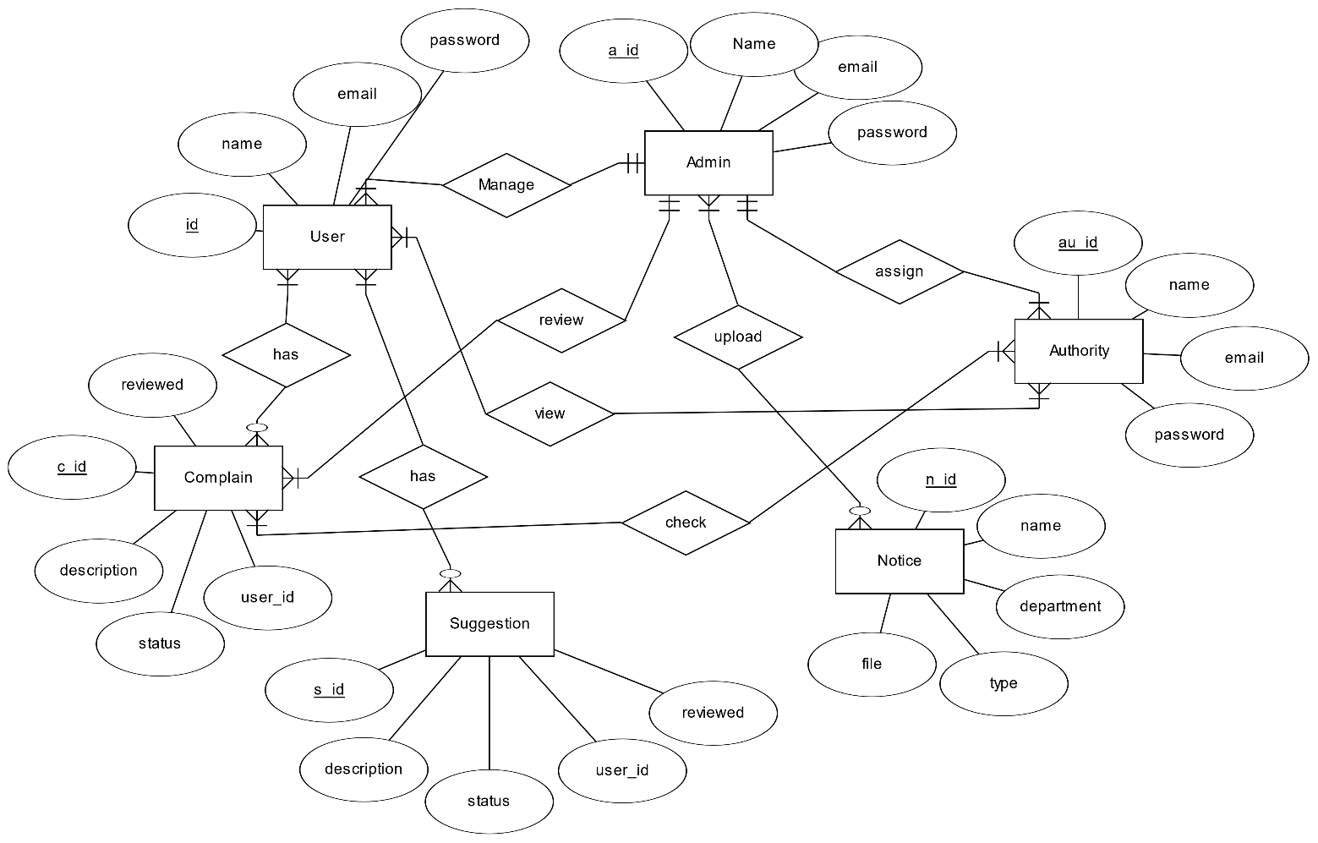

Fig 3.4.1 ERD Diagram [3]

## CHAPTER 04

# DEVELOPMENT TOOLS & TECHNOLOGY

### 4.1 User Interface Technologies

* HTML5, CSS, JavaScript, Bootstrap4, PHP, Laravel (Framework)
* jQuery 3.5.1
* Bootstrap
* Font Awesome, Material Icons

### 4.2 Implementation Technologies

#### 4.2.1 Xammp (7.4.16)

With its core components being the Apache HTTP Server, MariaDB database, and script interpreters for the PHP and Perl programming languages, Xampp is a free open-source web server solution built on the Apache platform. [4]

#### 4.2.2 NPM(6.X)

#### NPM is the biggest software registry and a package management for JavaScript. Find reusable code packages, then mix them in novel ways. [5]

#### 4.2.3 PHP 7.3.27

PHP employs hypertext. A general-purpose language for Web development is known as Preprocessor. [6]



### 4.3 Platform & Environment

#### 4.3.1 Hardware

* Processor: Intel core i3 (Minimum)
* RAM:4GB (Minimum)
* Hard Drive:1TB
* Ubuntu 14.04./ Windows 8.1/Windows 10

#### 4.3.2 Tools

* IDE: PhpStrom
* Command Prompt
* Server: LocalHost:8000

#### 4.3.3 Version Control

* Git

## CHAPTER 05

## SYSTEM TESTING

### 5.1 Introduction

### The purpose of system testing is to find flaws. This activity's major goal is to verify that the procedure is effectively conveyed and that all requirements are satisfied. System testing is important for assessing whether or not a function is functioning properly.

### 5.2 Test Case

A test case is a sequence of situations or depend on the particular will decide whether or not the system under test satisfied the requirement or worked properly. The developing process test case can assist in identifying an issue in an application's requirement or design.

### Test Case No -1

|  |  |
| --- | --- |
| Test Case ID.1 | Module name: User Login |
| Test Priority: High | Test Date:07.12.2021 |
| Test Title: User login | Test executed by: Omer Faruq Nadim |
| Description: Test User login page | Test executed date: 07.12.2021 |
| Pre-condition: | Users must have valid email and password. |
| Test steps: | 1. Go to login page 2. Provide valid email & password 3. Click Login button |
| Test Data: | User: Email: Nadim@gmail.com  Password: Test12345 |
| Expected Results: | User should able to login |
| Actual Result: | User logged in successfully |
| Status (Pass/Fail): | Pass |
| Post-condition: | Successfully Logged in. |

### Testing Case, No-2

|  |  |
| --- | --- |
| Test Case ID.2 | Module name: User Register |
| Test Priority: High | Test Date:22.10.2022 |
| Test Title: User Register | Test executed by: Omer Faruq Nadim |
| Description: Test User Register | Test executed date: 22.10.2022 |
| Pre-condition: | Users must have valid email and password. |
| Test steps: | 1. Go to Register page 2. Provide valid information 3. Click Register button |
| Test Data: | User: Email: Nadim@gmail.com  Password: Test12345 |
| Expected Results: | User should confirm email verification and logged on system |
| Actual Result: | User Register successfully |
| Status (Pass/Fail): | Pass |
| Post-condition: | Successfully Register. |

### Testing Case, No-3

|  |  |
| --- | --- |
| Test Case ID.3 | Module name: User Complain |
| Test Priority: High | Test Date:22.10.2022 |
| Test Title: User Complain Section | Test executed by: Omer Faruq Nadim |
| Description: Test User create complain page | Test executed date: 24.10.2022 |
| Pre-condition: | Users must enter valid information. |
| Test steps: | 1. Go to create complain page 2. Provide valid information and image. 3. Click submit button |
| Test Data: | Require Information |
| Expected Results: | User should able to create complain. |
| Actual Result: | User create complain successfully |
| Status (Pass/Fail): | Pass |
| Post-condition: | Successfully create complain. |

### Testing Case, No-4

|  |  |
| --- | --- |
| Test Case ID.3 | Module name: User Suggestion |
| Test Priority: High | Test Date:22.10.2022 |
| Test Title: User suggestion Section | Test executed by: Omer Faruq Nadim |
| Description: Test User create suggestion page | Test executed date: 24.10.2022 |
| Pre-condition: | Users must enter valid information. |
| Test steps: | 1. Go to create suggestion page 2. Provide valid information. 3. Click submit button |
| Test Data: | Require Information |
| Expected Results: | User should able to create suggestion. |
| Actual Result: | User create suggestion successfully |
| Status (Pass/Fail): | Pass |
| Post-condition: | Successfully create suggestion. |

## CHAPTER 06

## USER MANUAL

### 6.1 User manual

### FOR User

#### 6.1.1 User login page [7]

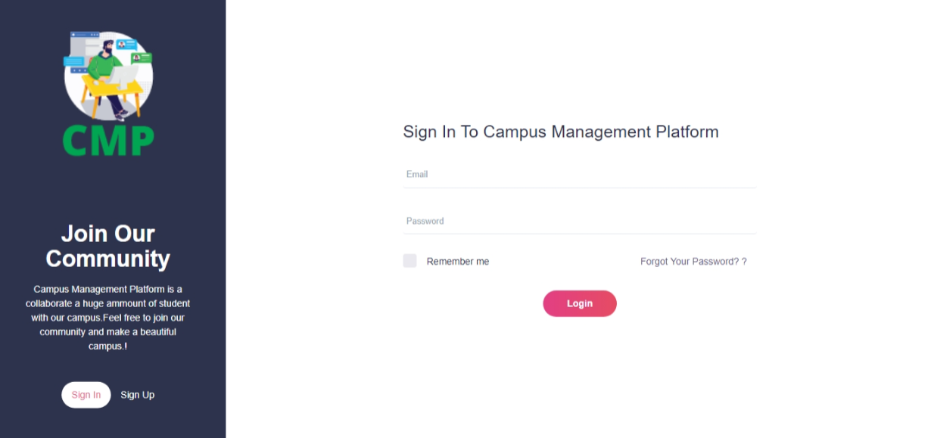

Fig 6.1.1 User Login page

#### 6.1.2 User Registration page

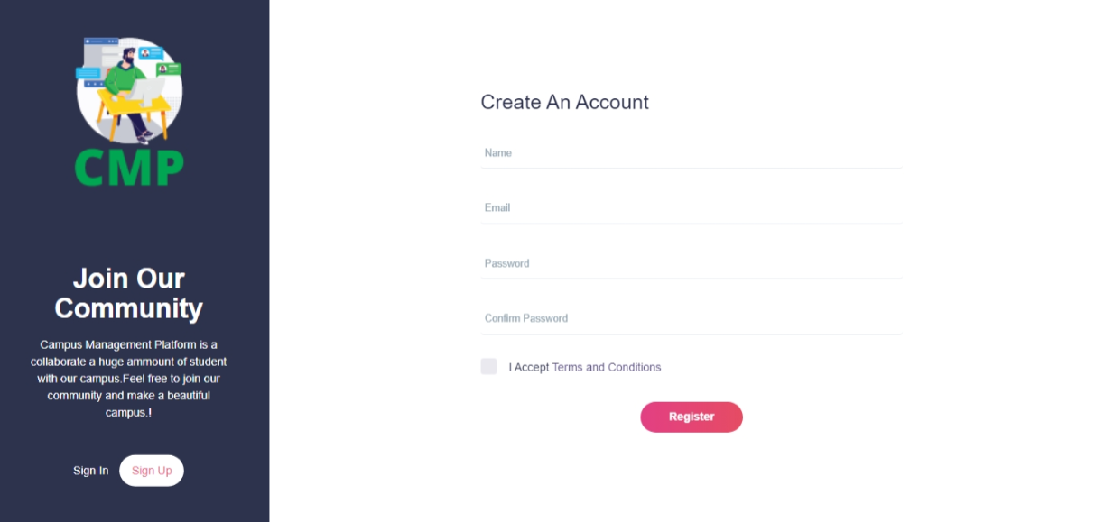

Fig 6.1.2 User Registration page

#### 6.1.3 User Dashboard

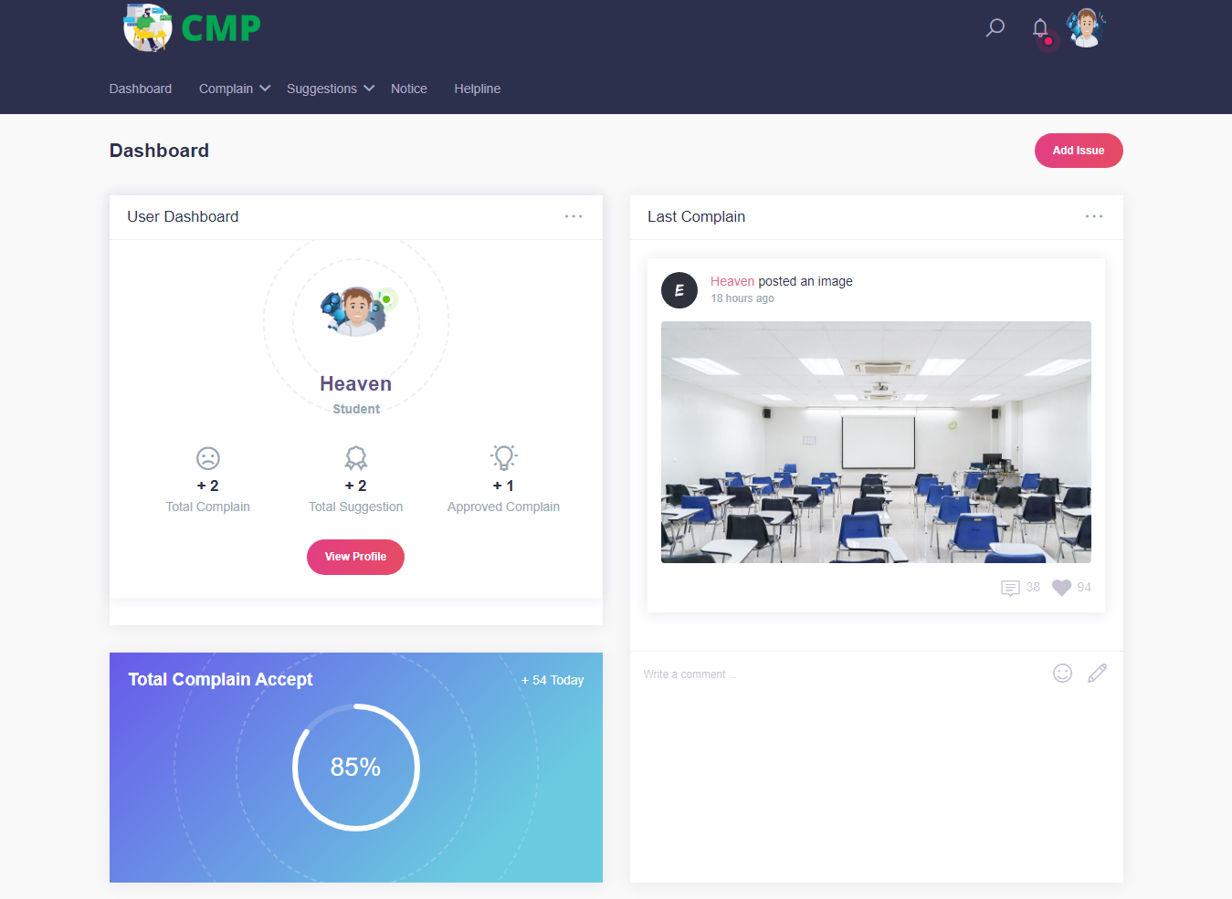

Fig 6.1.3.1 User Dashboard 1

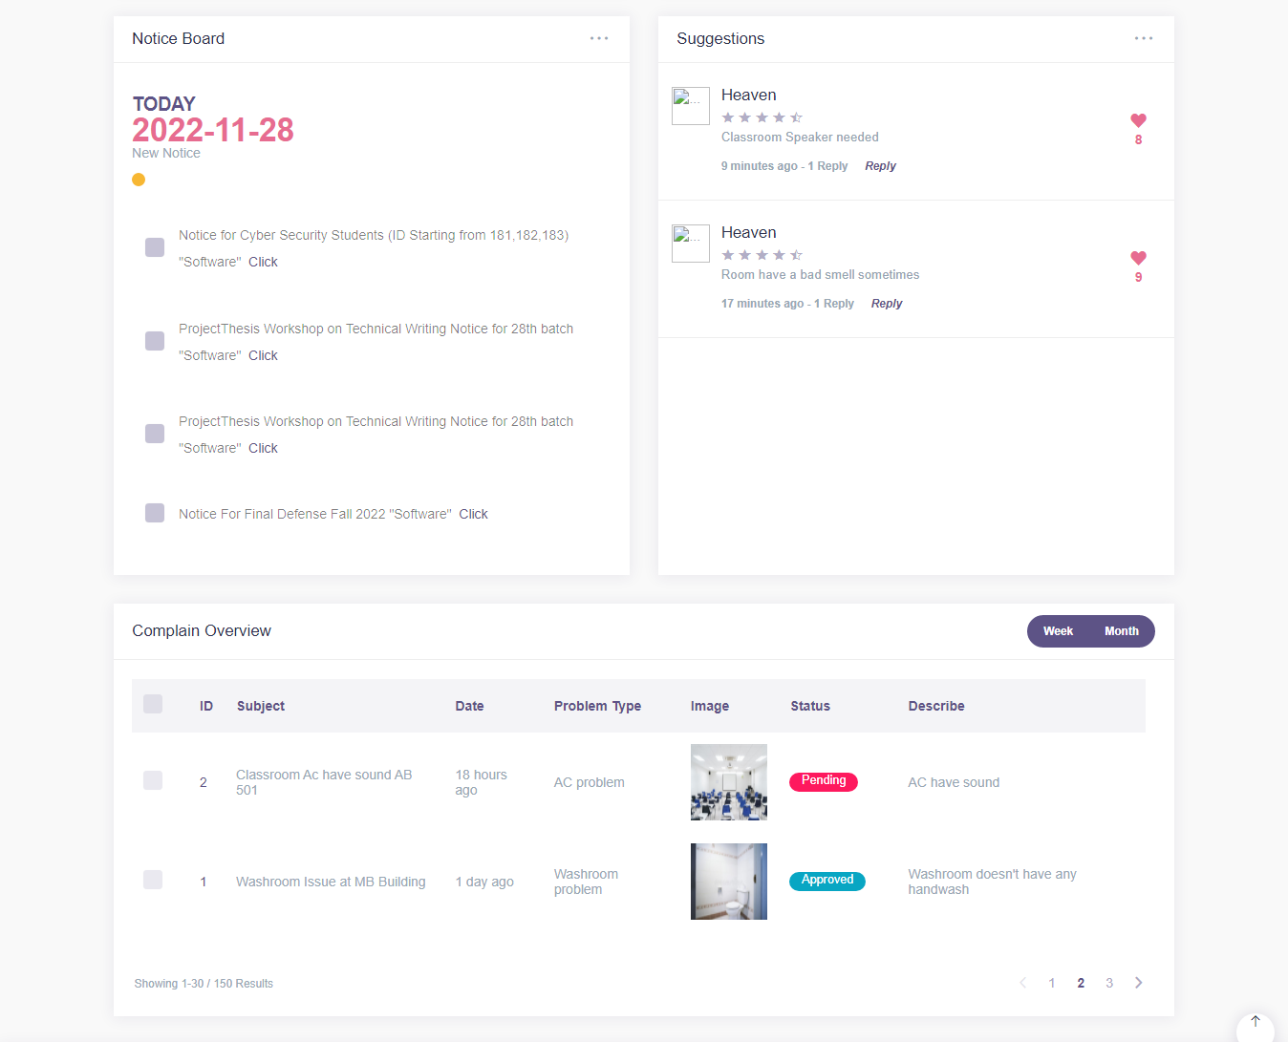

Fig 6.1.3.2 User Dashboard 2

#### 6.1.4 User Complain

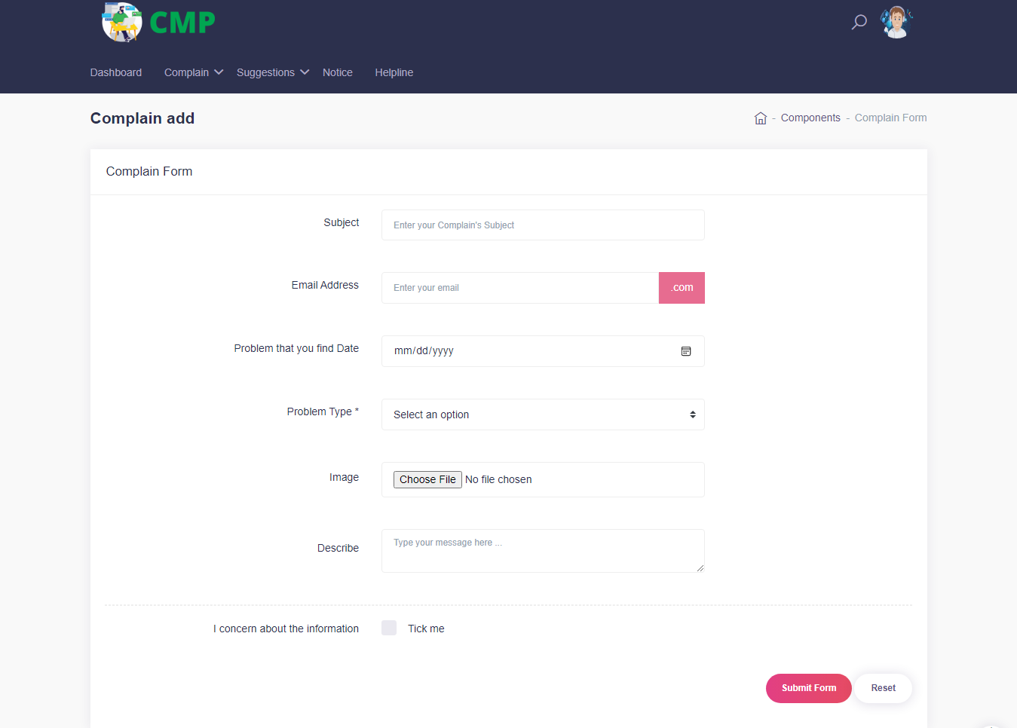

Fig 6.1.4 User Complain

#### 6.1.5 User Complain View

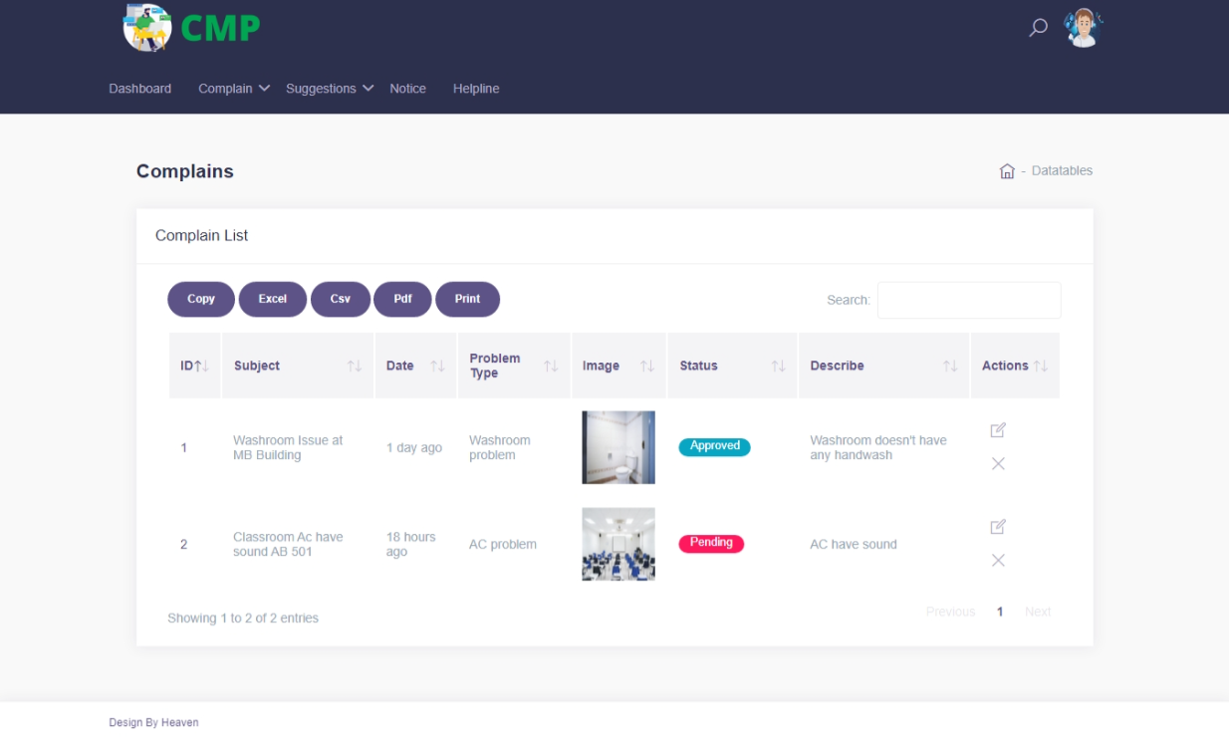

Fig 6.1.4 User Complain View

#### 6.1.5 User Suggestion

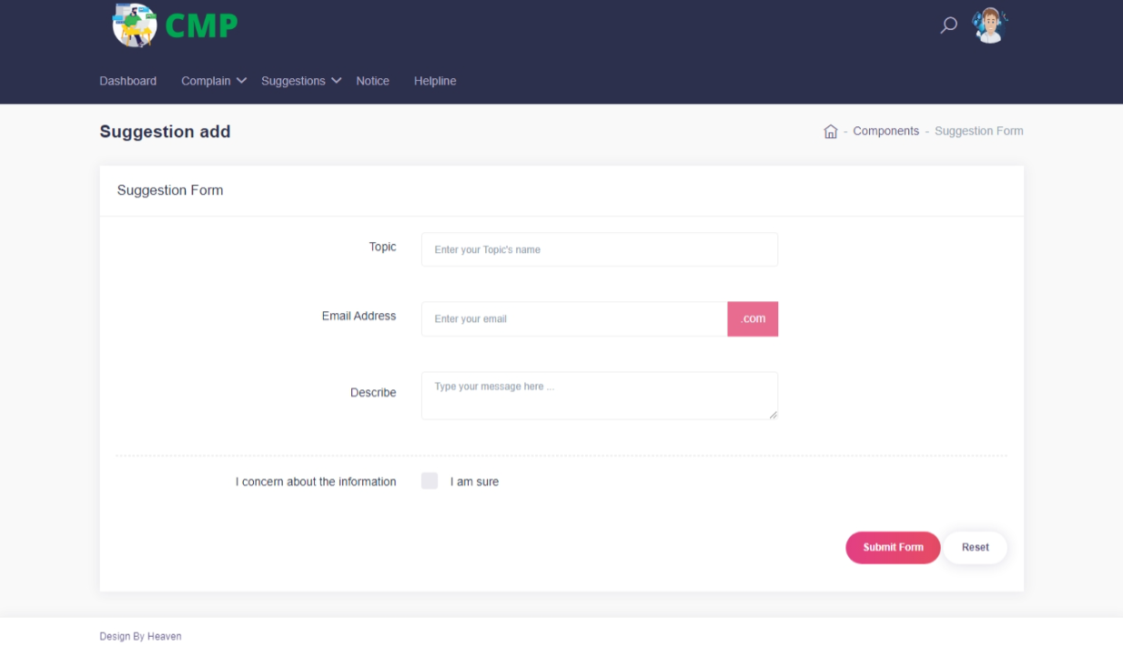

Fig 6.1.5 User Suggestions

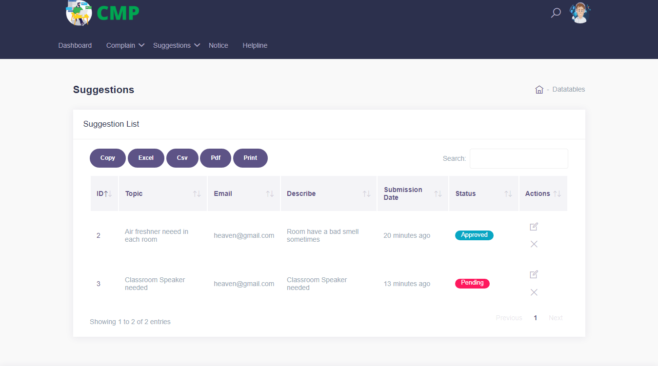

6.1.6 User Suggestion View

#### 6.1.7 User Notice Board View

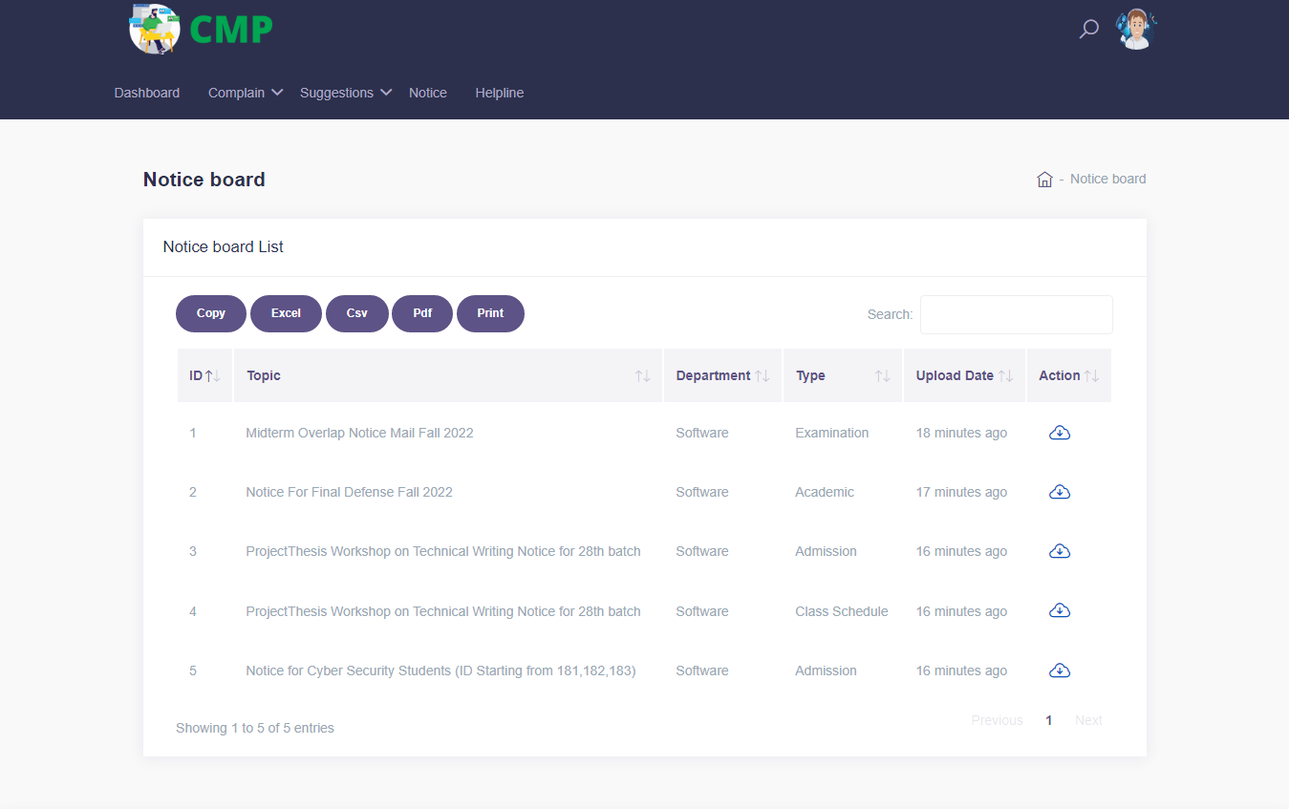

Fig 6.1.7 User Notice Board View

#### 6.1.8 User Helpline

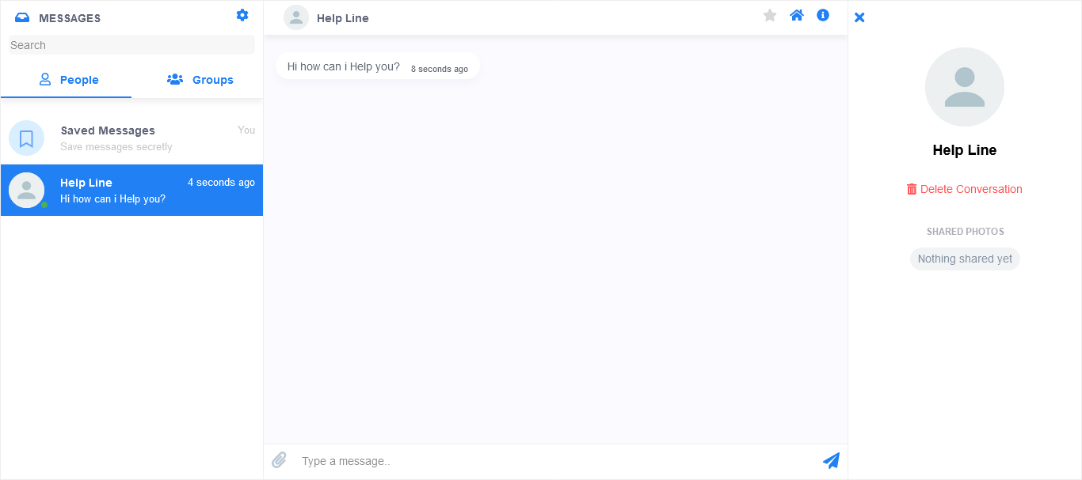

Fig 6.1.8 User Helpline

#### 6.1.9 User Profile

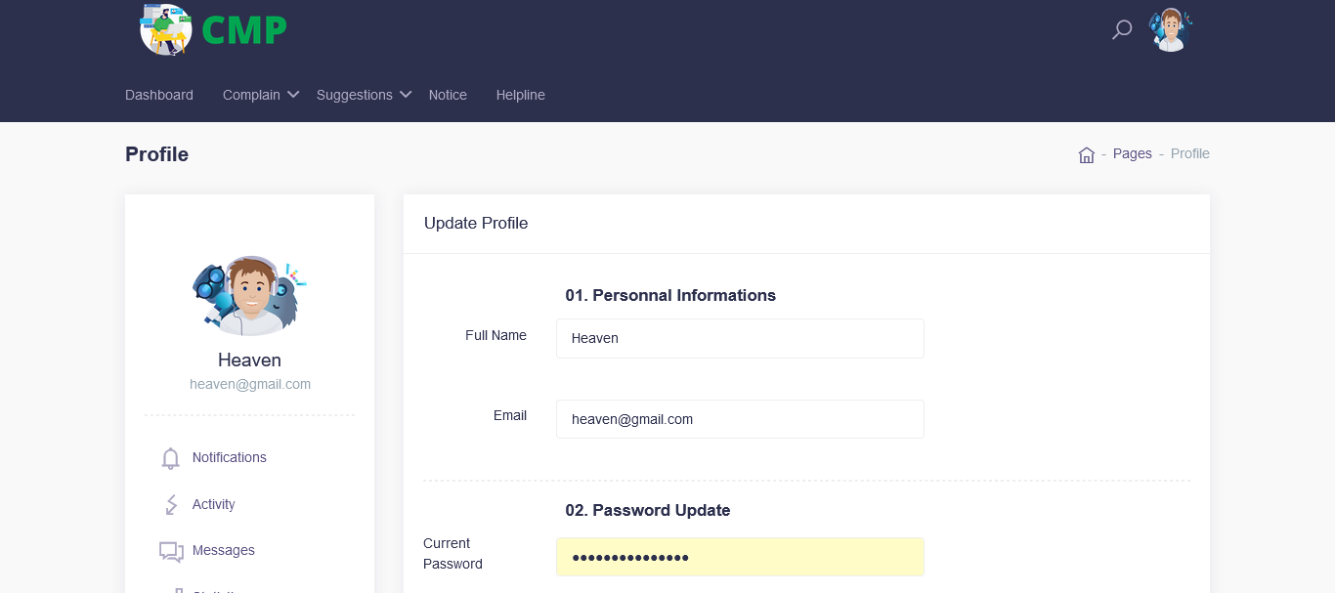

Fig 6.1.9 User Profile

#### 6.1.10 User Notification

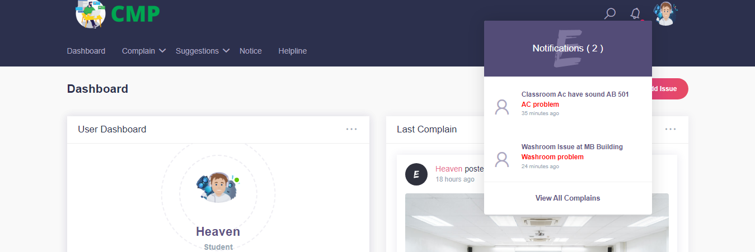

Fig 6.1.10 User Notification

### For Admin

#### 6.2.1 Admin Login

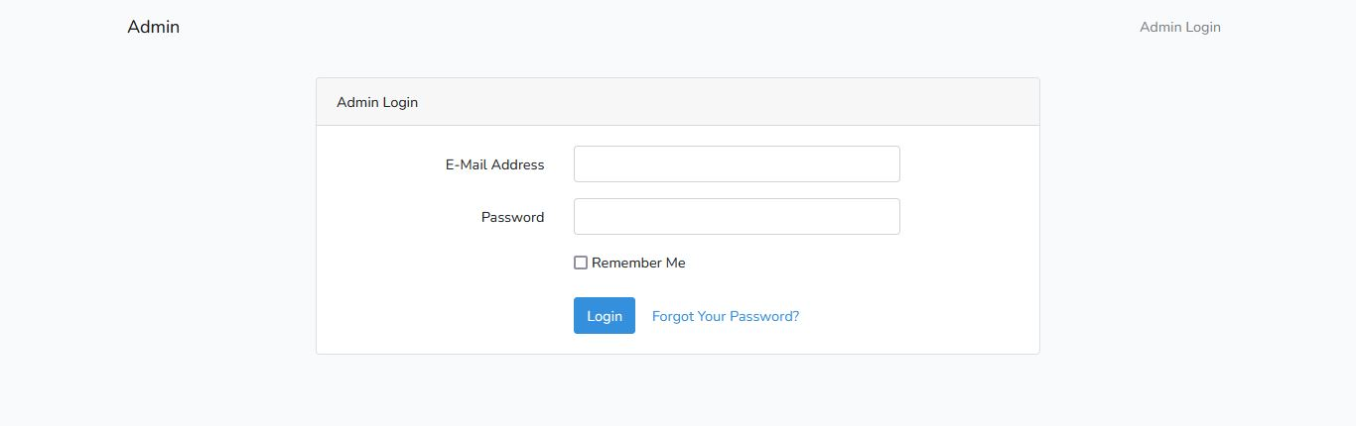

Fig 6.2.1 Admin Login

#### 6.2.2 Admin Dashboard

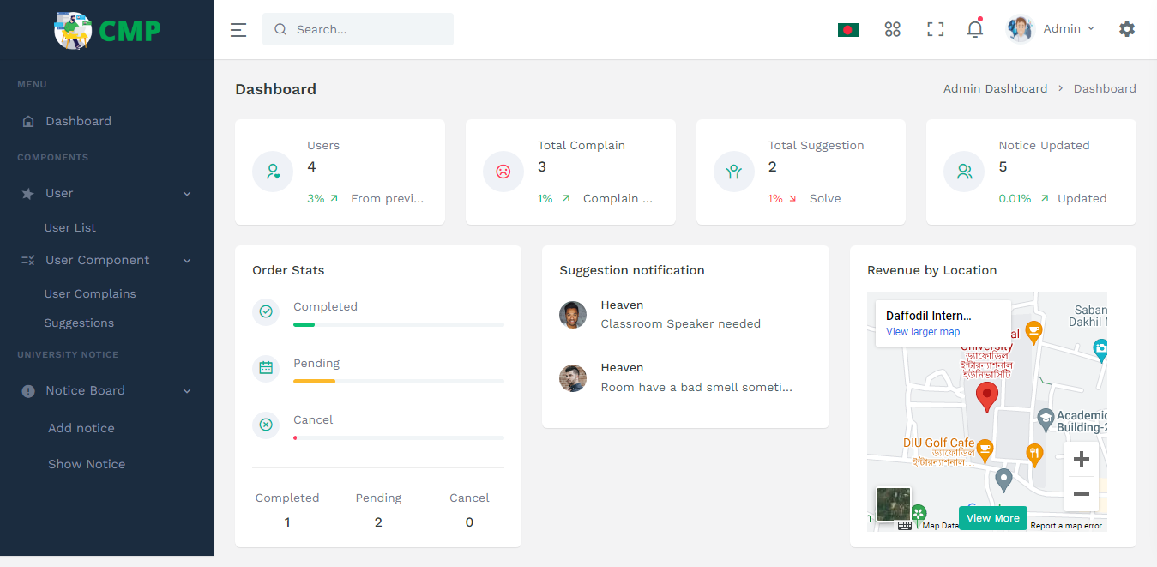

Fig 6.2.2 Admin Dashboard

#### 6.2.3 Admin User List

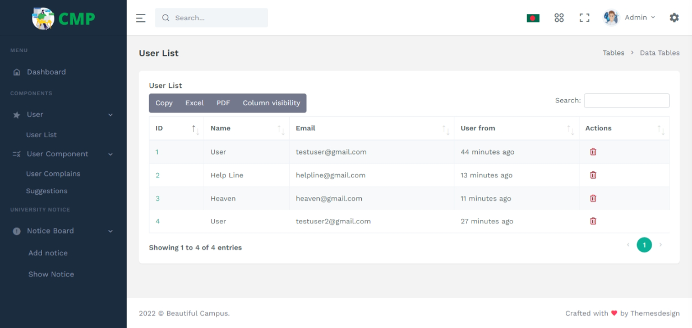

Fig 6.2.3 Admin User List

#### 6.2.4 Admin User Complain

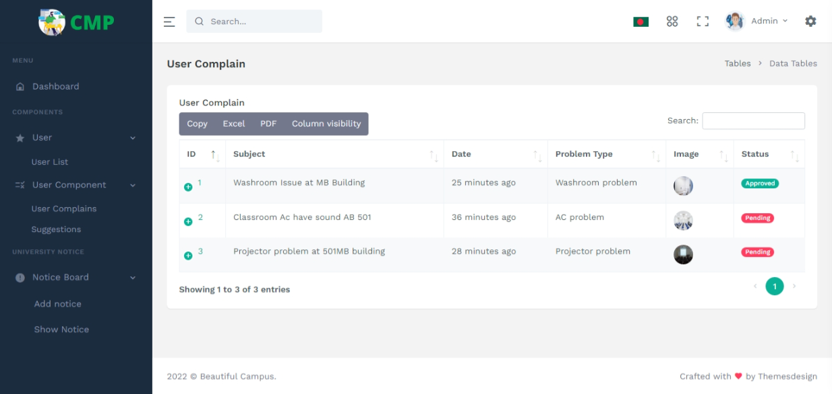

Fig 6.2.4 Admin User Complain

#### 6.2.5 Admin User Suggestions

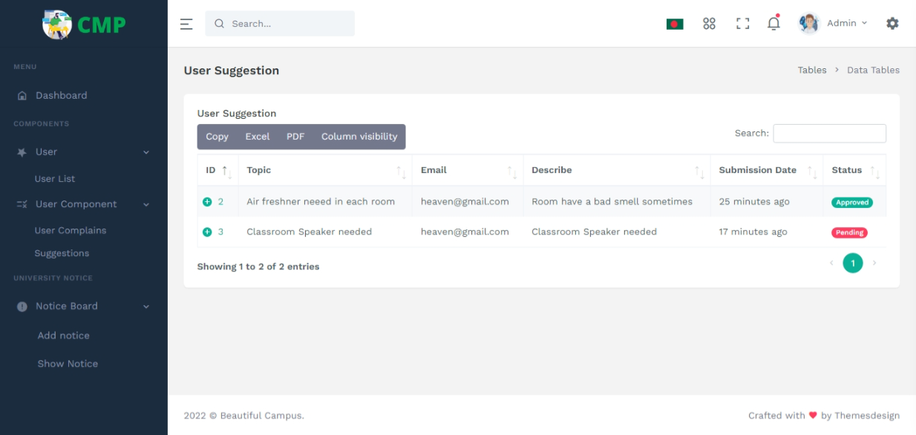

Fig 6.2.5 Admin User Suggestions

#### 6.2.6 Admin Notice Add



Fig 6.2.6 Admin Notice Add

#### 6.2.7 Admin Notice Show

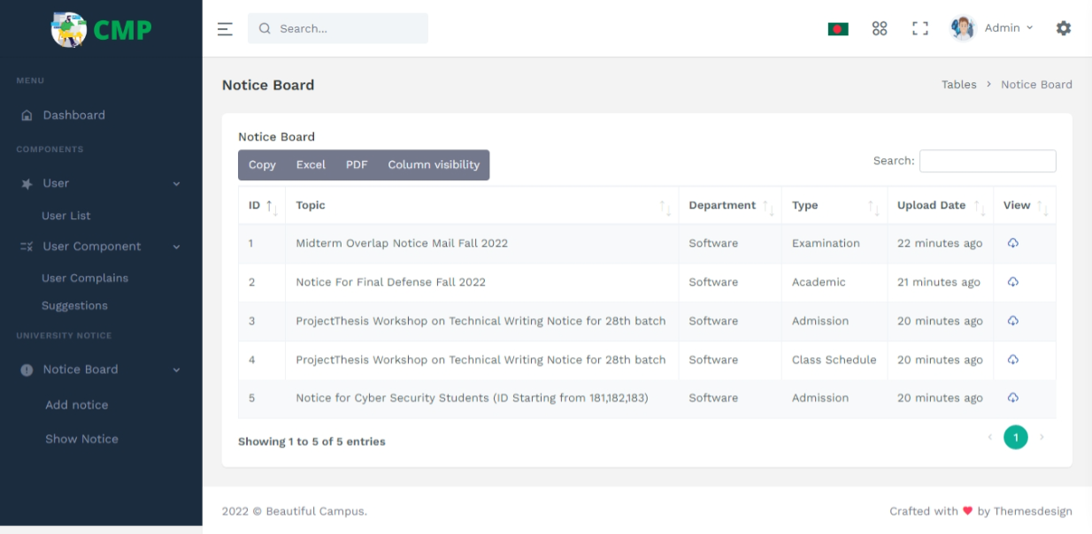

Fig 6.2.7 Admin Notice Show

#### 6.2.8 Admin User Complain Approve

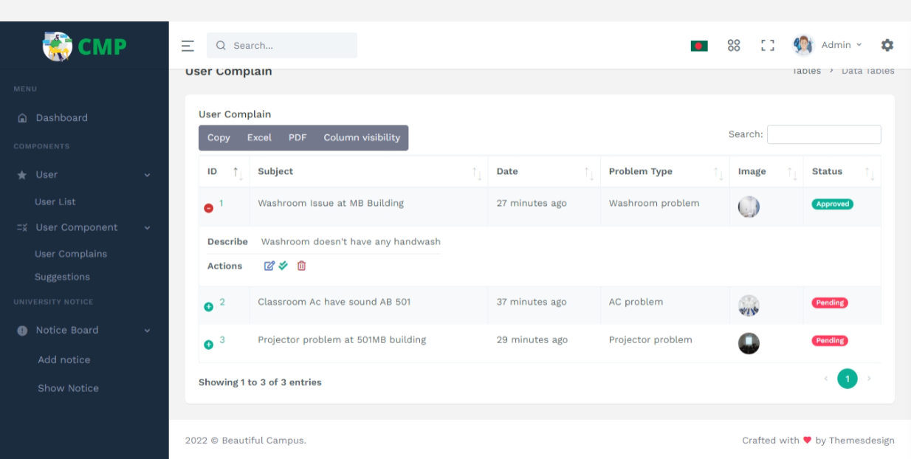

Fig 6.2.8 Admin User Complain Approve

#### 6.2.9 Admin Profile Update



Fig 6.2.9 Admin profile password update

### For Authority

#### 6.3.1 Authority Login



Fig 6.3.1 Authority Login

#### 6.3.2 Authority Dashboard

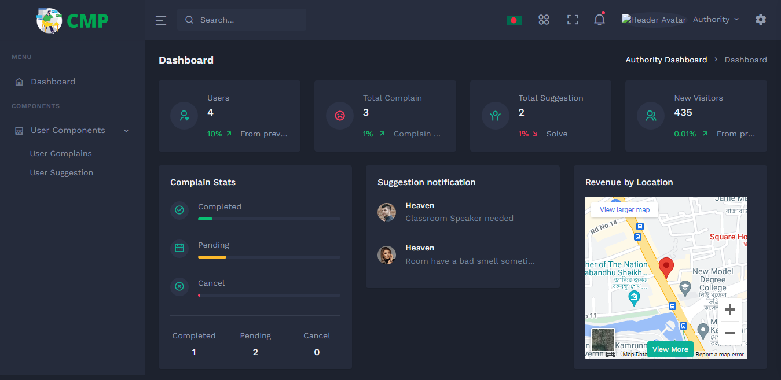

Fig 6.3.2 Authority Dashboard

#### 6.3.3 Authority Dashboard 2

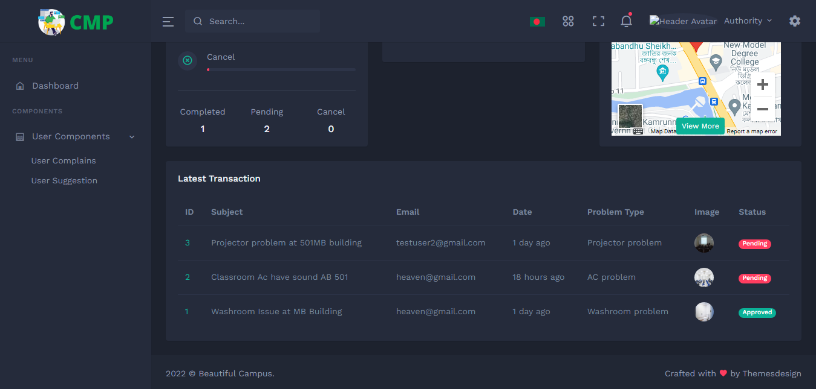

Fig 6.3.3 Authority Dashboard 2

#### 6.3.4 Authority User Complain

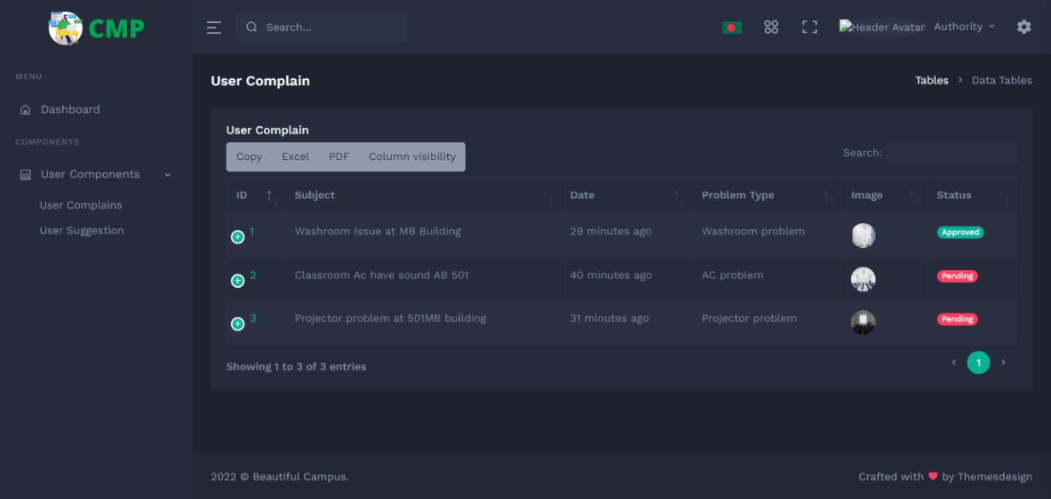

Fig 6.3.4 Authority User Complain

#### 6.3.5 Authority User Suggestion

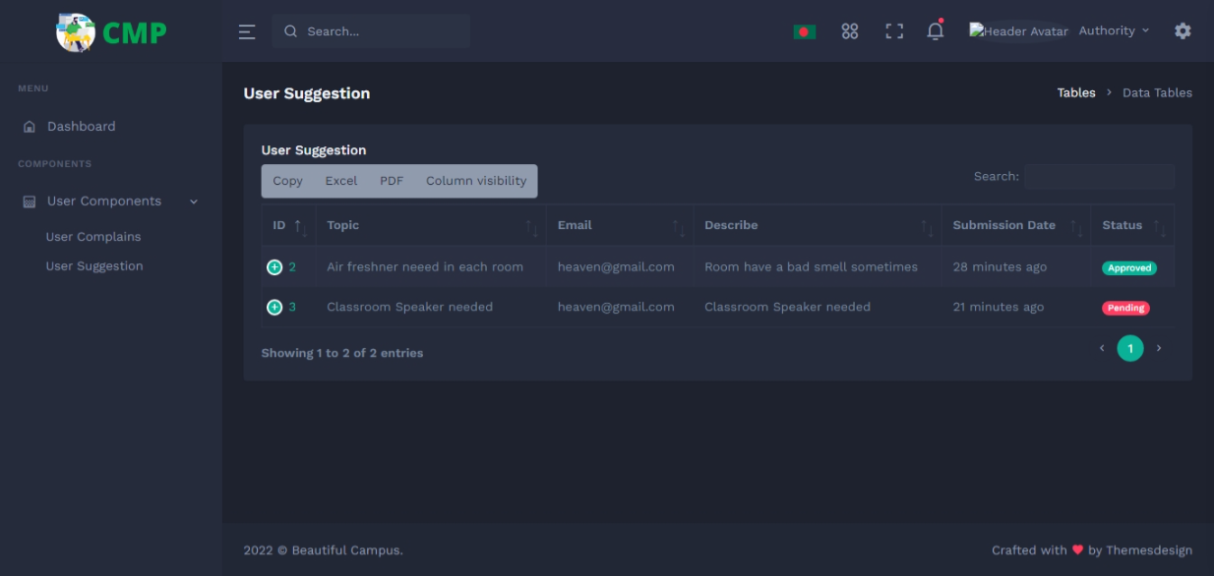

Fig 6.3.5 Authority User Suggestion

#### 6.3.6 Authority User Complain Approve

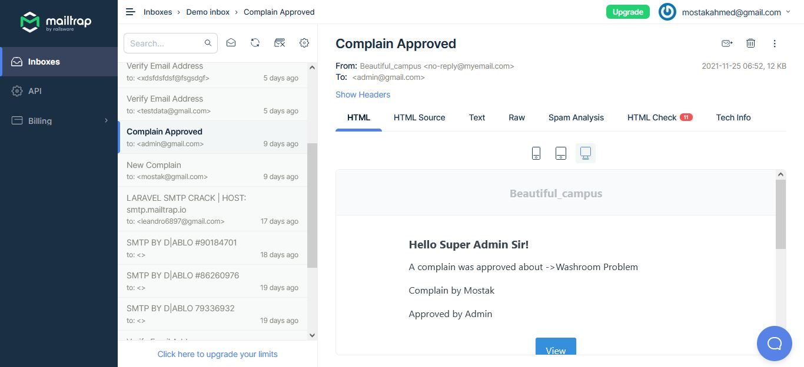

Fig 6.3.6 Authority User Complain Approve

#### 6.3.6 Authority Profile update

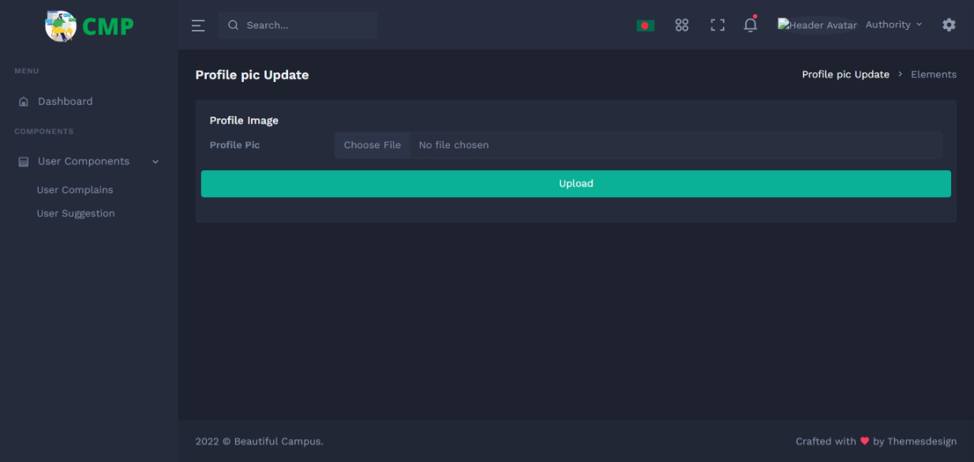

Fig 6.3.7 Authority Profile Update

## CHAPTER 07

## PROJECT SUMMARY

### 7.1 GitHub Link:

### 7.2 Limitations:

* The user has to have fast internet.
* The system does not accept accounts that have not been authorized, thus users must have active accounts to use it.

### 7.3 Obstacle & Achievement

### Obstacle:

* Time and money constraints;
* learning new technologies and surroundings.

### Achievement:

* Time and money constraints
* learning new technologies and surroundings

### 7.4 Future Work

In the future, we'll upload this project to a live server and work to address some significant problems so that students can use the website to access this service.

# References

|  |  |
| --- | --- |
| [1] | PNGTEM, Software Development Agile Model, 2019. |
| [2] | Lucid Chart, "Lucidchart," 2022. |
| [3] | ERDplus, "ERDplus," 2021. |
| [4] | XAMPP Apache + MariaDB + PHP, 2018. |
| [5] | NPM, NPM docs, 2019. |
| [6] | Php 8.1.1, Php. |
| [7] | Laravel. |